**Bugs Report**

**UCC-Java Release Summer 2019**

**Introduction :**

This bugs found report is based on **UCC-G 1.3.1**.

The **test files path** : ucc_unified⁩ ▸ ⁨all_files⁩ ▸ ⁨dr_class⁩ ▸ ⁨5_Projects⁩ ▸ ⁨Test_Suite⁩ ▸ ⁨2018_2_Summer⁩ ▸ ⁨RobotFramework⁩ ▸ ⁨Final_Deliverables⁩ ▸ ⁨final_code⁩ ▸ ⁨rootframe-java-0726⁩ ▸ ⁨Framework⁩ ▸ ⁨lang⁩

The bugs below are all **unfixed** bugs.

**Bug 1:**

**Description :**

About language **Bash**, the **some features and count numbers** are different between two versions.

**Test Files :**

/ucc_input / bash/ input_one/ *

**Path or file name :**

c++bash1/outfile_cplx.csv

java_bash1/outfile_cplx.csv

**Outputs :**

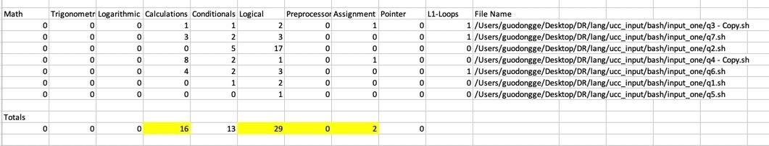

c++bash1/outfile_cplx.csv

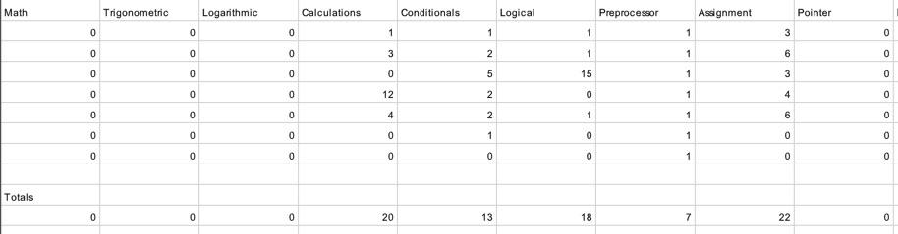

java_bash1/outfile_cplx.csv

There are so may differences between two versions. The keywords for cpp and java are the same. I need to compare file by file.

As for q4-copy.sh, the difference is Java has 4 more calculation. It’s clearly that it takes option into account. So this is clearly the bug of Java version. 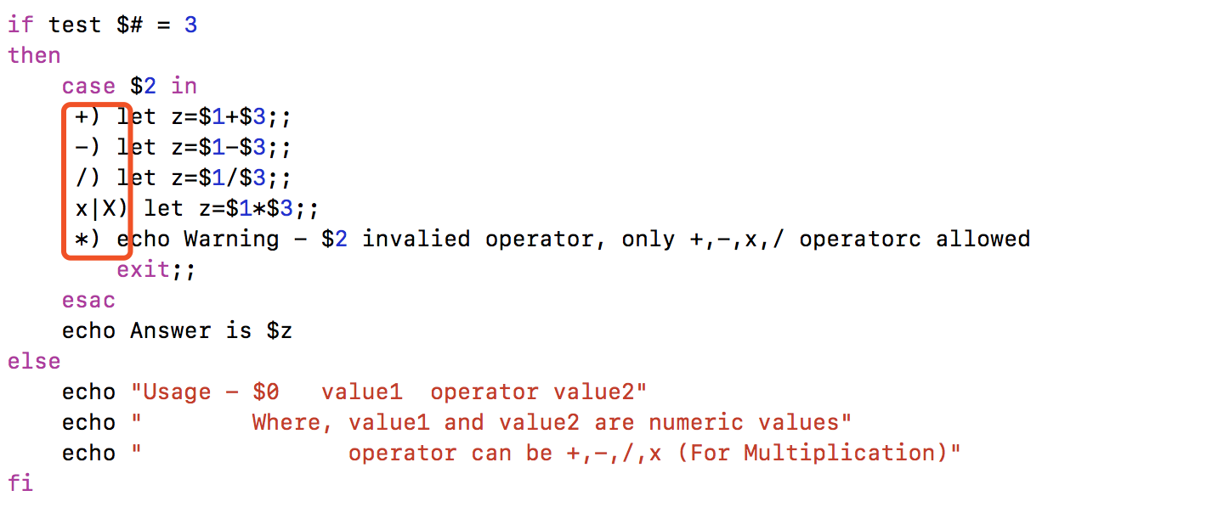

As for the preprocessing. Java assume “#!”(keywords) as the evidence of preprocessing.

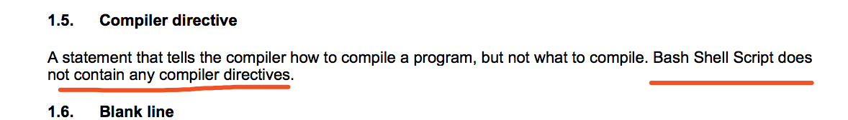

So I have commented the compile directive keywords, so as for preprocessing part, there are no differences between cpp version and java version.

As for the assignment part, I think java version is right but there still exist a bug.

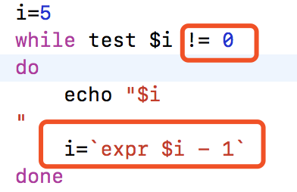

i!=0 shouldn’t be an assignment statement but the code in the following red box should be an assignment statement. This should be an assignment statement.

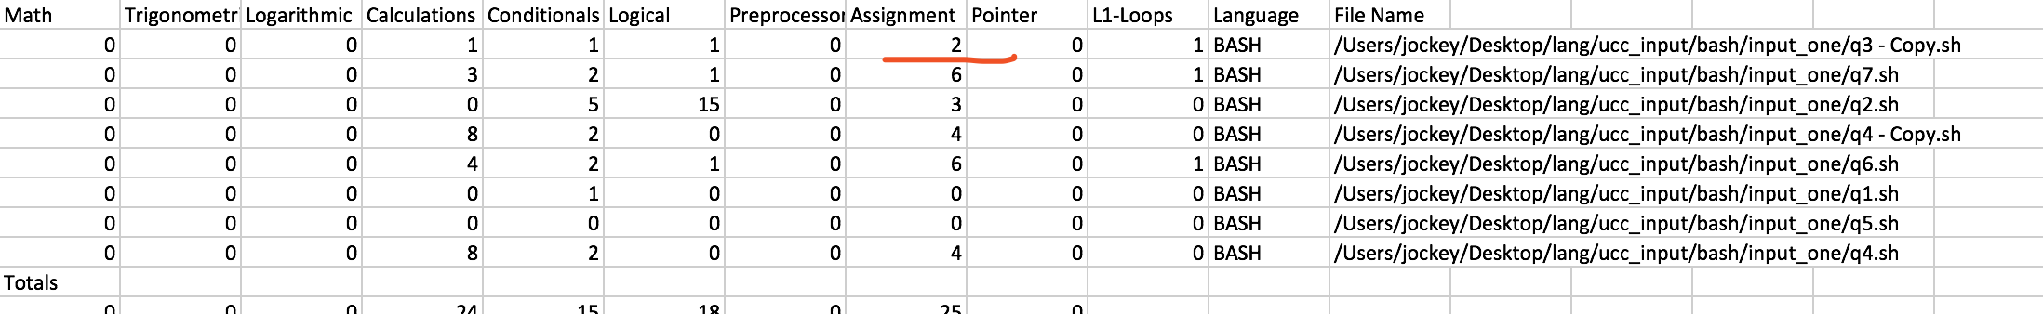

**Bug 2:**

**Description :**

About language **Bash**, the **some value of Calculations** are different between two versions.

**Path or file name :**

c++bash1/outfile_cplx.csv

java_bash1/outfile_cplx.csv

**Test Files :**

/ucc_input / bash / input_one/ *

**Outputs :**

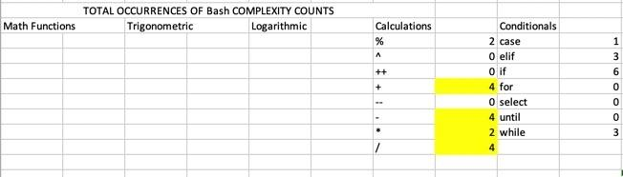

c++bash1/outfile_cplx.csv

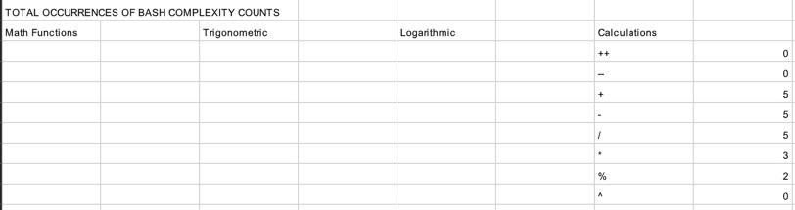

java_bash1/outfile_cplx.csv

**Bug 3:**

**Description :**

About language **Batch**, the **some values of CC1** are different between two versions.

**Test Files :**

/ucc_input / bash / input_one/ *

**Path or file name :**

c++batch1/outfile_cyclomatic_cplx.csv

java_batch1/outfile_cyclomatic_cplx.csv

**Outputs :**

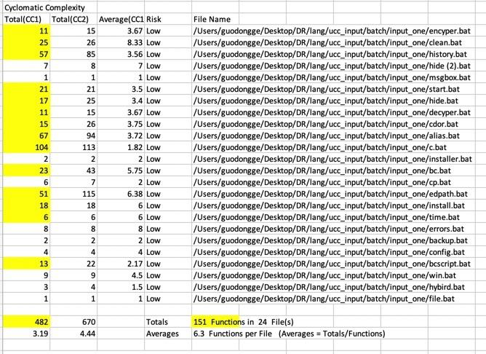

c++batch1/outfile_cyclomatic_cplx.csv

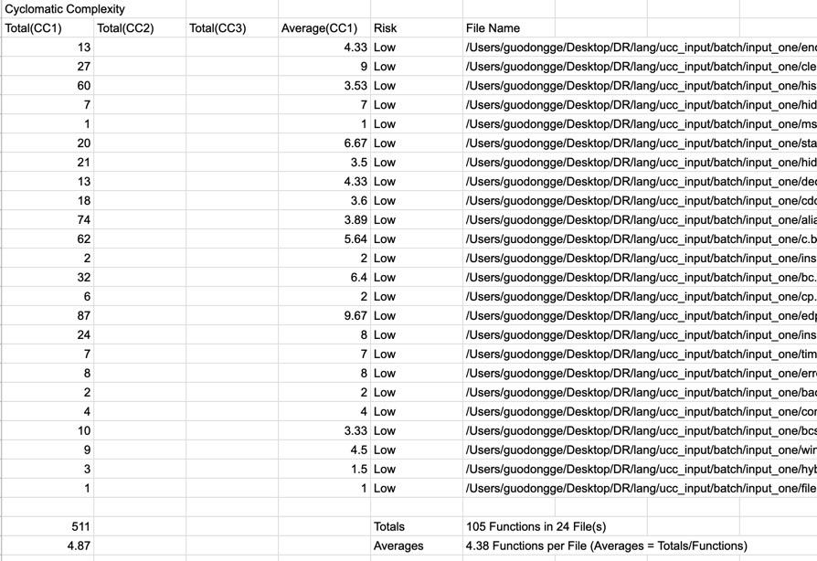

java_batch1/outfile_cyclomatic_cplx.csv

**Bug 4:**

**Description :**

About language **Batch**, the **some function names in C++ are main, but in java they are empty.**

**Test Files :**

/ucc_input / batch / input_one/ *

**Path or file name :**

c++batch1/outfile_cyclomatic_cplx.csv

java_batch1/outfile_cyclomatic_cplx.csv

**Outputs :**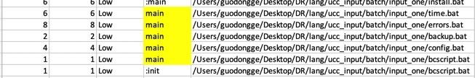

c++batch1/outfile_cyclomatic_cplx.csv



java_batch1/outfile_cyclomatic_cplx.csv

**Bug 5:**

**Description :**

About language **Batch**, **some values of CC1** are different between two versions.

**Test Files :**

/ucc_input / batch / input_one/ *

**Path or file name :**

c++batch1/DOS_Batch_outfiles.csv

java_batch1/DOS_Batch_outfiles.csv

**Outputs :**

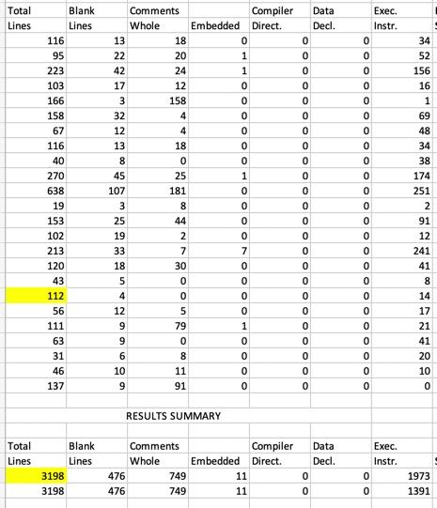

c++batch1/DOS_Batch_outfiles.csv

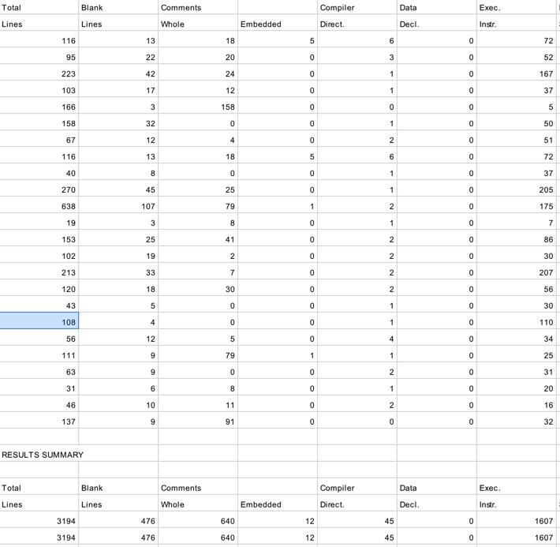

java_batch1/DOS_Batch_outfiles.csv

**Bug 6:**

**Description :**

About language **Batch**, **Some count numbers** are different between two versions.

**Test Files :**

/ucc_input / batch / input_one/ *

**Path or file name :**

c++batch1/outfiles_cplx.csv

java_batch1/outfiles_cplx.csv

**Outputs :**

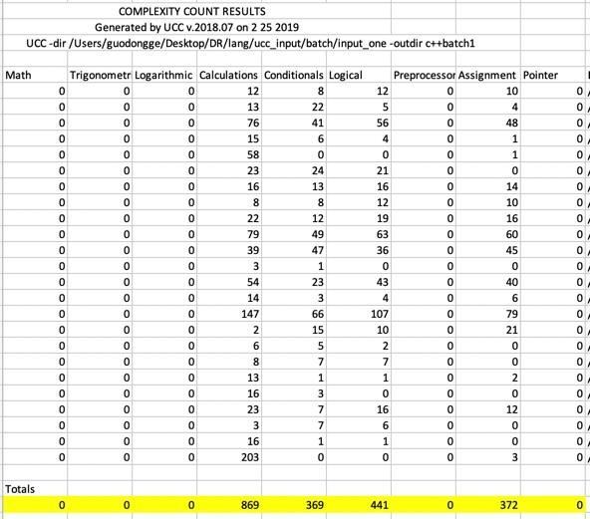 c++batch1/DOS_Batch_outfiles.csv

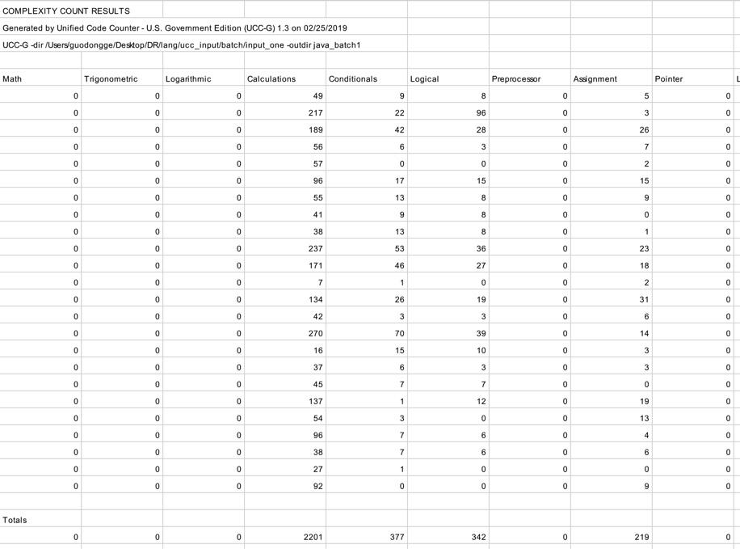

java_batch1/DOS_Batch_outfiles.csv

**Bug 13:**

**Description :**

About language **C#**, **Some CC1** are different between two versions.

**Test Files :**

/ucc_input / c# / input_one/ *

**Path or file name :**

c++c#1/outfiles_cyclomatic_cplx.csv

java_c#1/outfiles_cyclomatic_cplx.csv

**Outputs :**

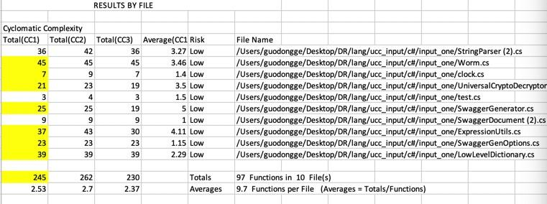

c++c#1/outfiles_cyclomatic_cplx.csv

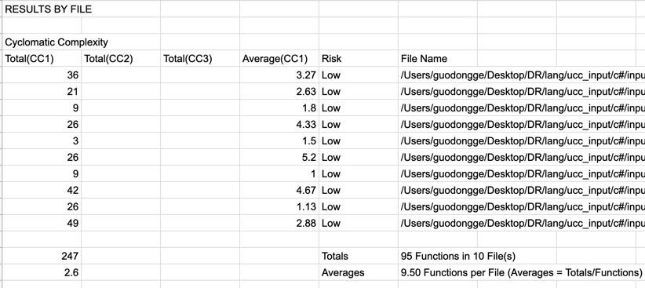

java_c#1/outfiles_cyclomatic_cplx.csv

**Bug 7:**

**Description :**

About language **C#**, **Some values** are different between two versions.

**Test Files :**

/ucc_input / c# / input_one/ *

**Path or file name :**

c++c#1/outfiles_cyclomatic_cplx.csv

java_c#1/outfiles_cyclomatic_cplx.csv

**Outputs :**

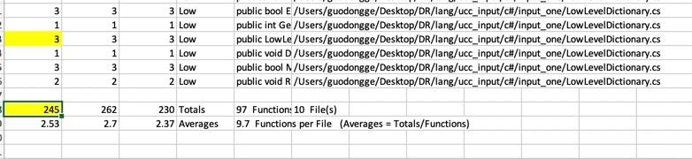

c++c#1/outfiles_cyclomatic_cplx.csv

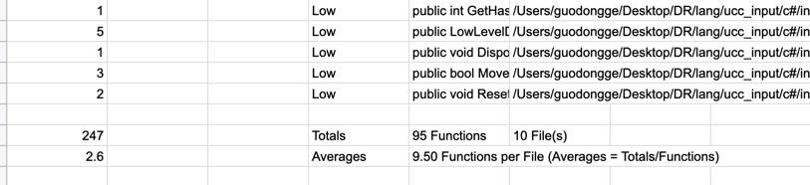

java_c#1/outfiles_cyclomatic_cplx.csv

**Bug 8:**

**Description :**

About language **C#**, **Some function names** are different between two versions.

**Test Files :**

/ucc_input / c# / input_one/ *

**Path or file name :**

c++c#1/outfiles_cyclomatic_cplx.csv

java_c#1/outfiles_cyclomatic_cplx.csv

**Outputs :**

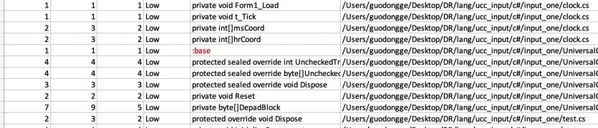

c++c#1/outfiles_cyclomatic_cplx.csv

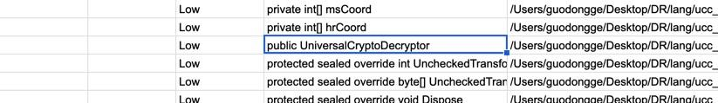

java_c#1/outfiles_cyclomatic_cplx.csv

**Bug 9:**

**Description :**

About language **Coldfusionscript**, both UCC-C++ AND UCC-java have no output files.

**Test Files :**

/ucc_input / coldfusionscript / *

/ucc_input / coldfusionscript / *

**Path or file name :**

c++coldfusionscript1/

java_coldfusionscript1/

c++coldfusionscript2/

java_coldfusionscript2/

**Outputs :**

No outputs of UCC-JAVA and UCC-C++

**Bug 10:**

**Description :**

About language **cshell**, both UCC-C++ and UCC-JAVA the number of files is 11 files. The executable keywords of two versions are different, such as the keyword : **if, echo, exit.**

For example, about keyword **exit**, the UCC-C++ reports **7** but UCC-JAVA reports **8**. After check the 11 input files(total 12 files, but no test.csh), I found **9** exit. So, I think it is a bug of UCC-JAVA and UCC-C++.

**Test Files :**

/ucc_input / cshell / input_one

**Path or file name :**

UCC -dir /Users/guodongge/Desktop/DR/lang/ucc_input/cshell/input_one -outdir c++cshell1

UCC-G -dir /Users/guodongge/Desktop/DR/lang/ucc_input/cshell/input_one -outdir java_cshell1

CSHELL_outfile

**Outputs :**

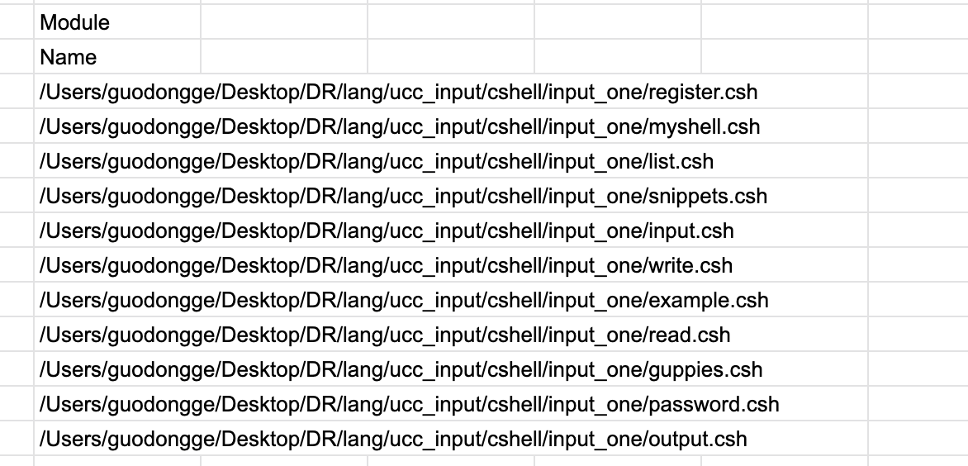

**11 files**

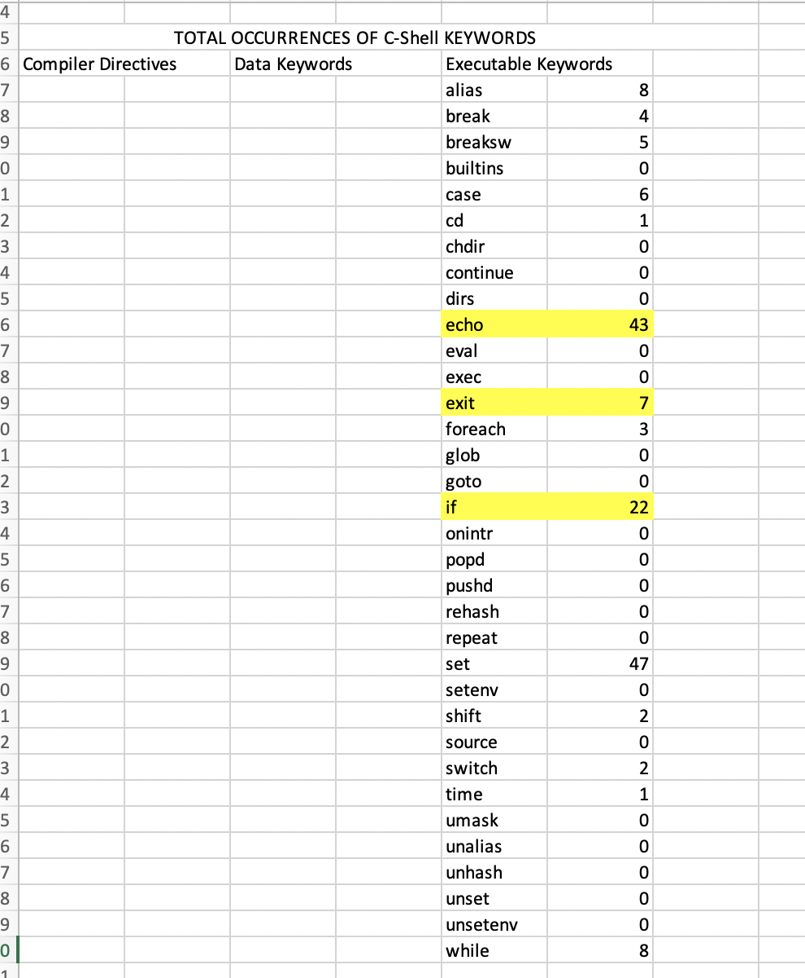

CSHELL_outfile of UCC-C++

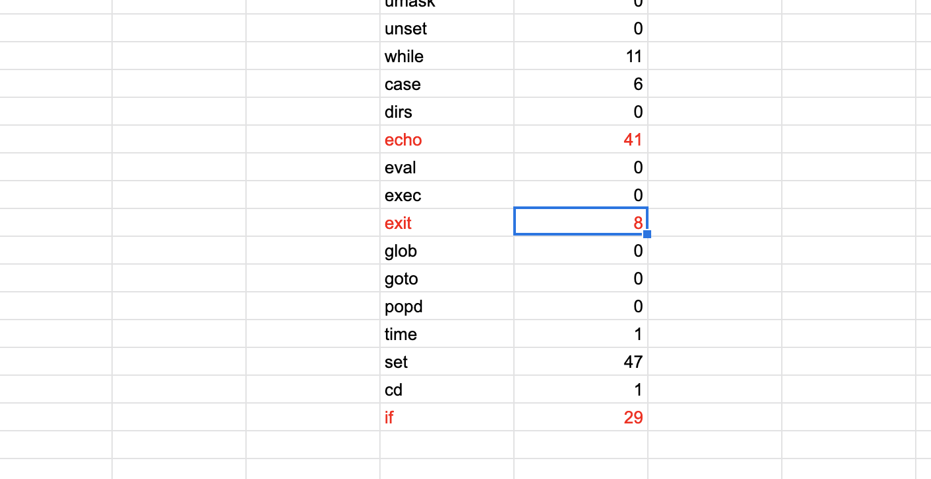

CSHELL_outfile of UCC-java

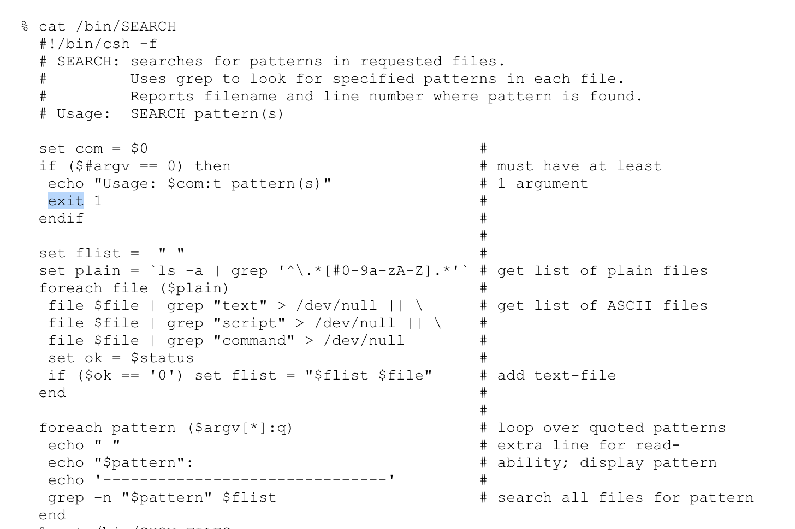

**write.csh**

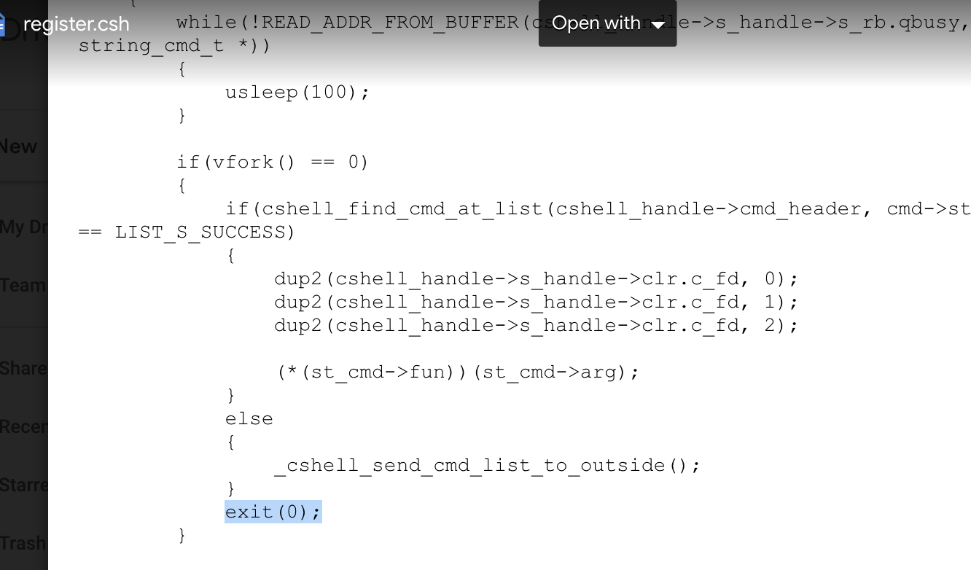

**register.csh**

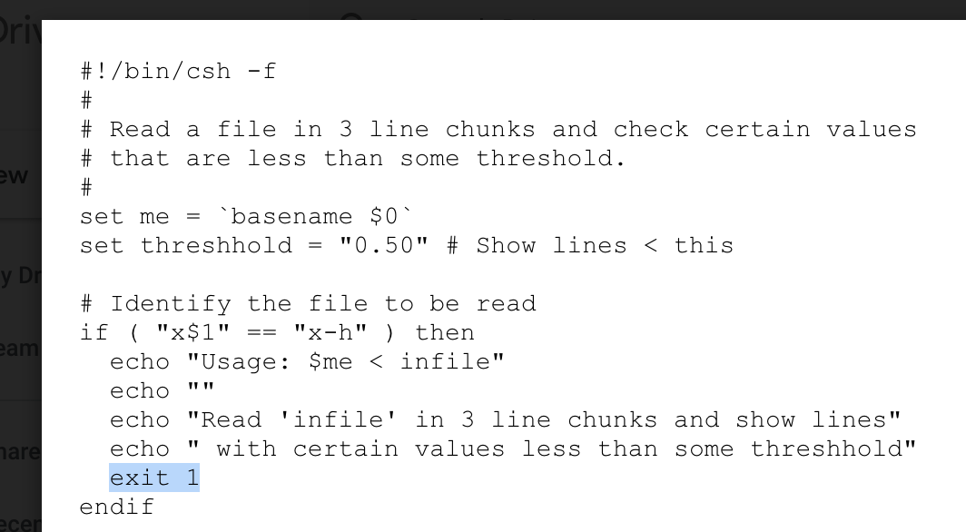

**read.csh**

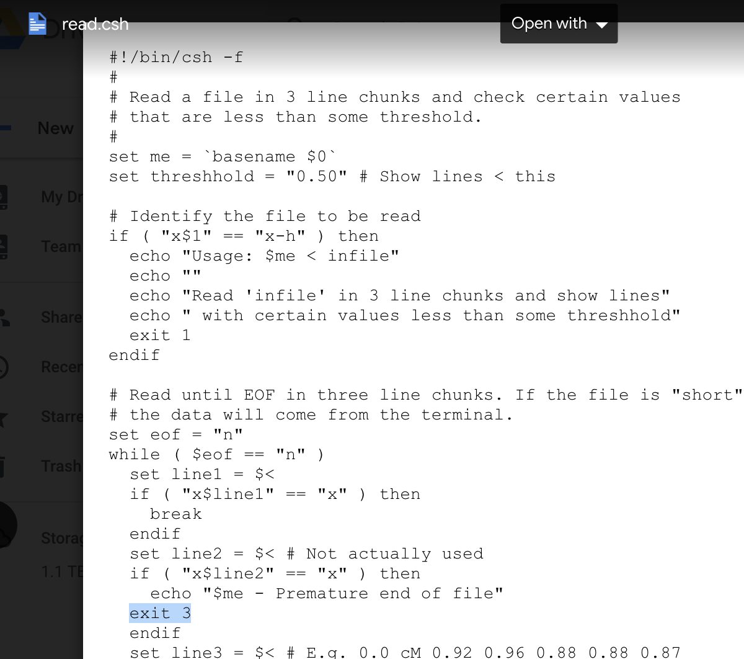

**read.csh**

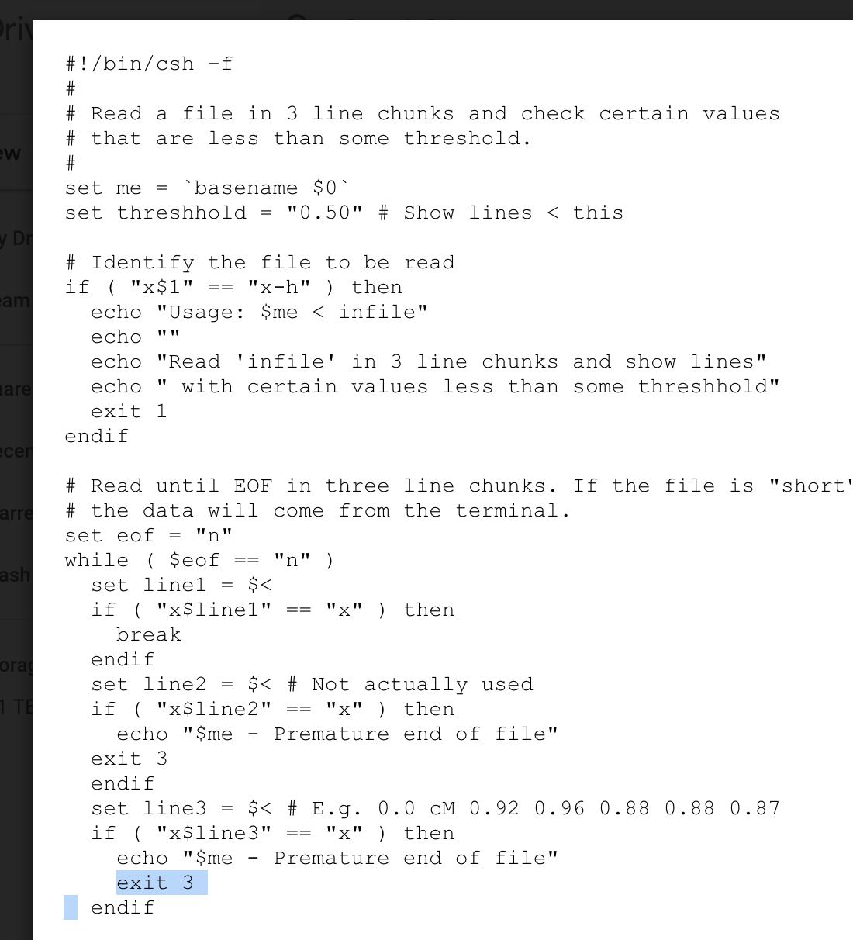

**read.csh**

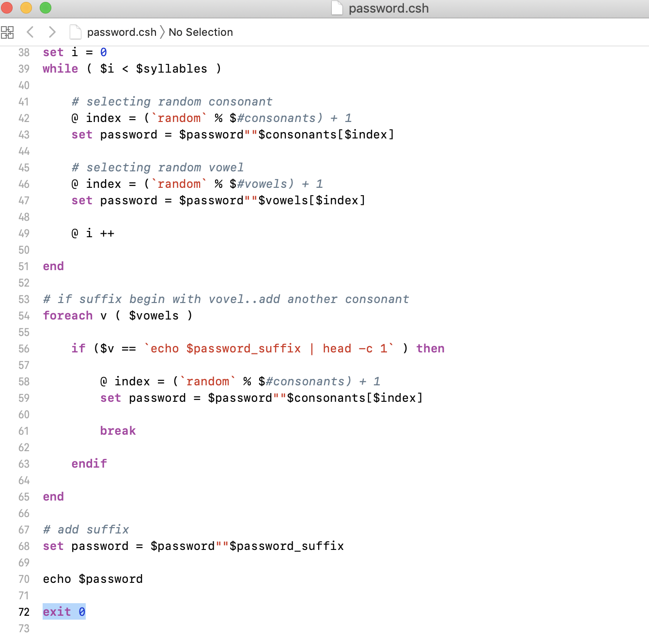

**password.csh**

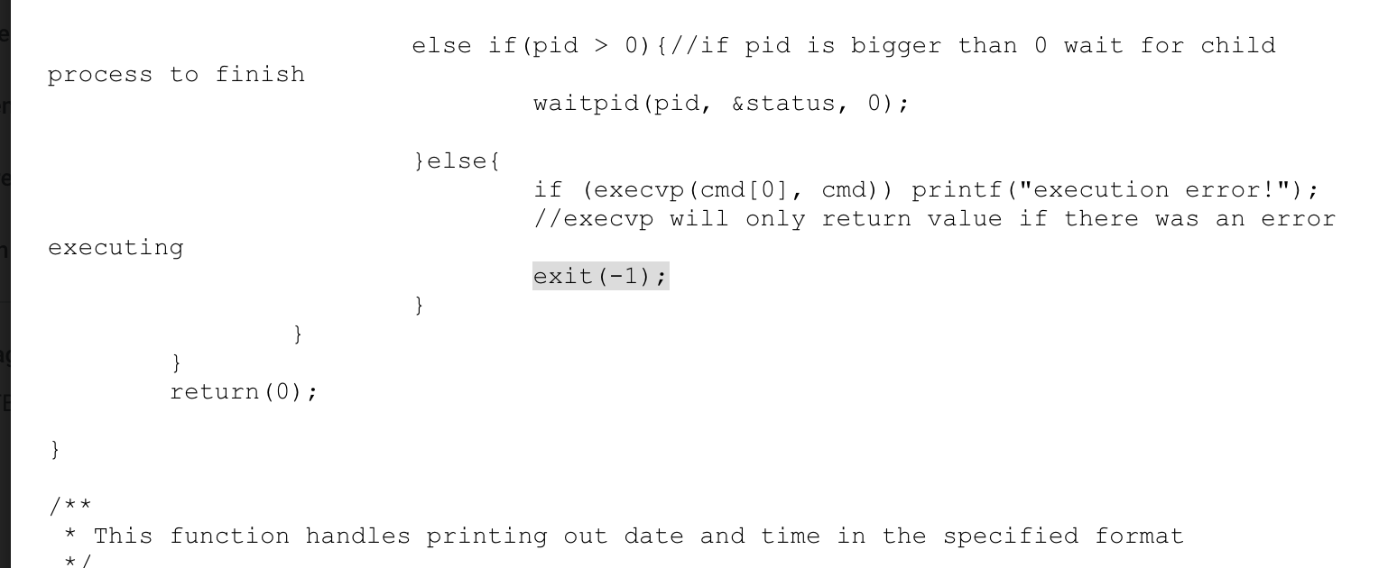

**myshell.csh**

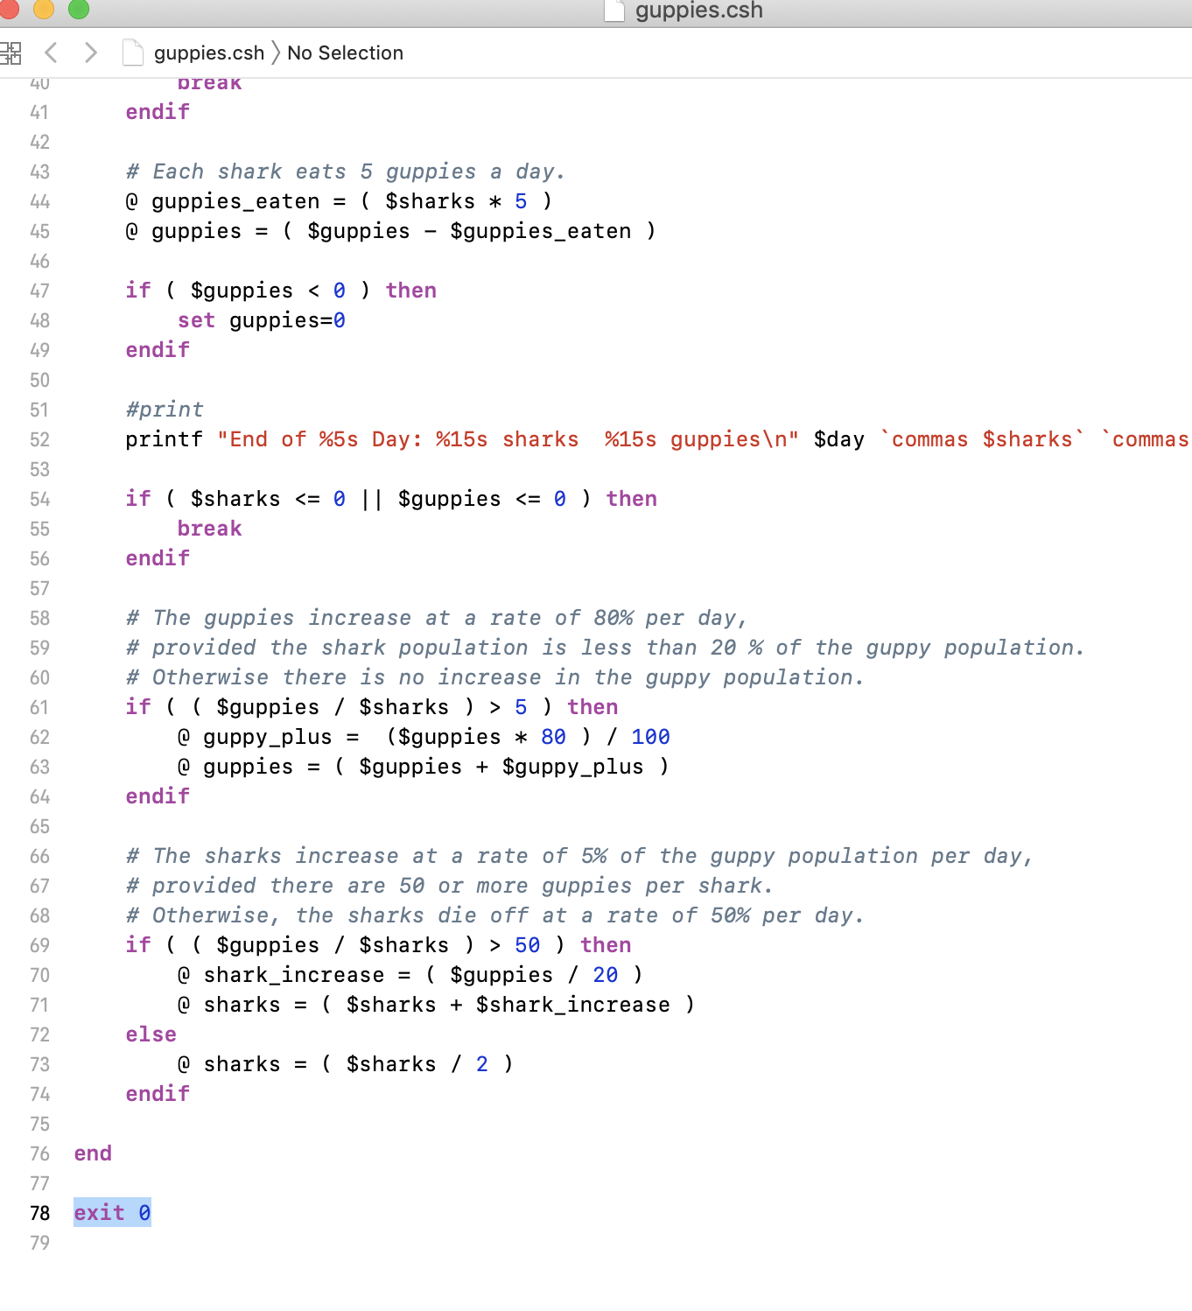

**guppies.csh**

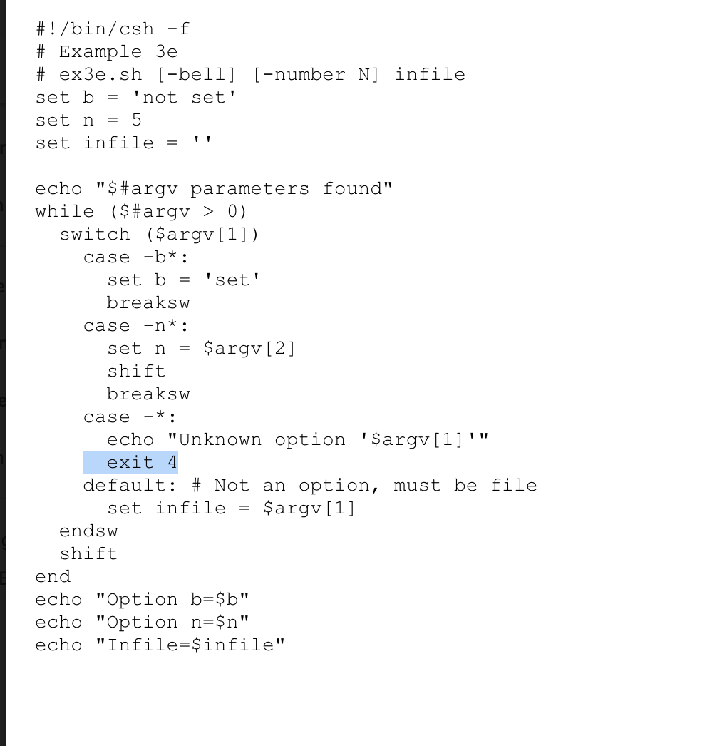

**example.csh**

**Bug 11:**

**Description :**

About language **fortran**, the **total functions** is different between two versions. In UCC-C++, all functions are considered as main function and in UCC-JAVA, the function count number also incorrect..

**Test Files :**

/ucc_input / fortran/ input_one/ *

**Path or file name :**

c++fortran1/outfile_cyclomatic_cplx

java_fortran1/outfile_cyclomatic_cplx

**Outputs :**

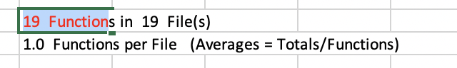

**total functions in UCC-C++**

**c++fortran1/outfile_cyclomatic_cplx**

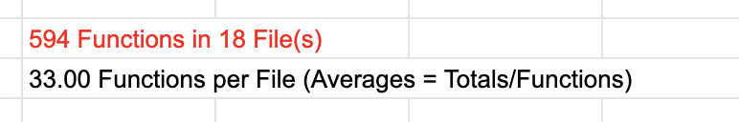

**total functions in UCC-java**

**hava_fortran1/outfile_cyclomatic_cplx**

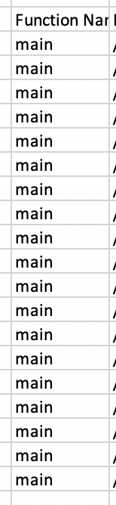

**ucc-c++**

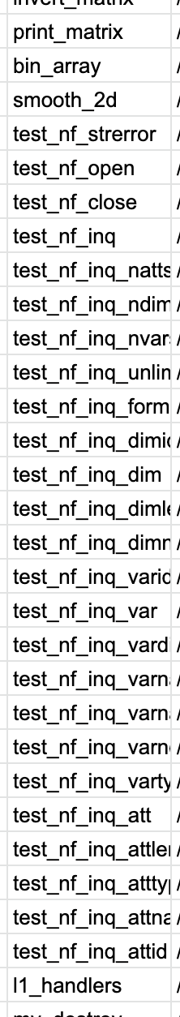

**ucc-java**

**For example of file constants.f90**

**In UCC-java, three functions are found;**

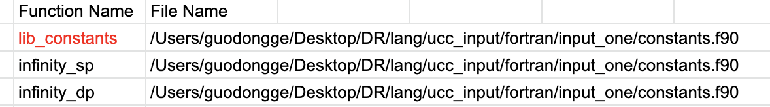

**In UCC-C++, all the functions are considered as main function**



**But actually, here just two functions. So, UCC-JAVA and UCC-C++ do incorrect count.** 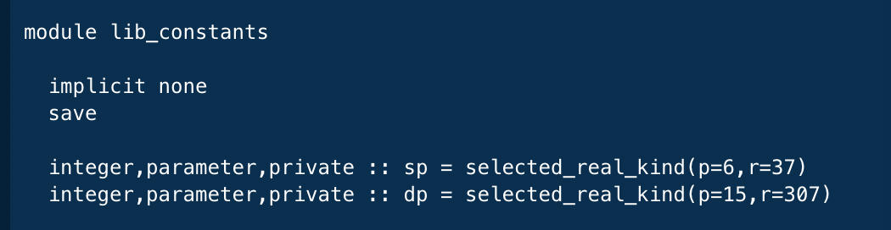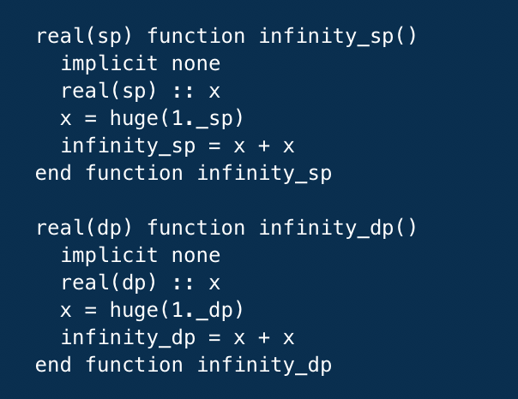

**Bug 12:**

**Description :**

About language **fortran**, the **CC1 count** is different between two versions. And UCC-java may do the incorrect thing.

**Test Files :**

/ucc_input / fortran / input_one/ *

**Path or file name :**

c++fortran1/outfile_cyclomatic_cplx

java_fortran1/outfile_cyclomatic_cplx

**Outputs :**

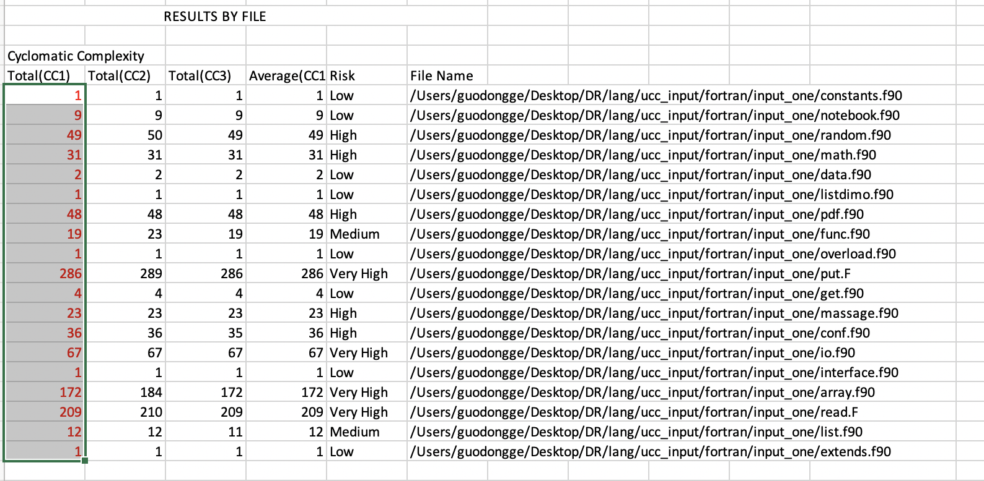

**c++fortran1/outfile_cyclomatic_cplx(result by file)**

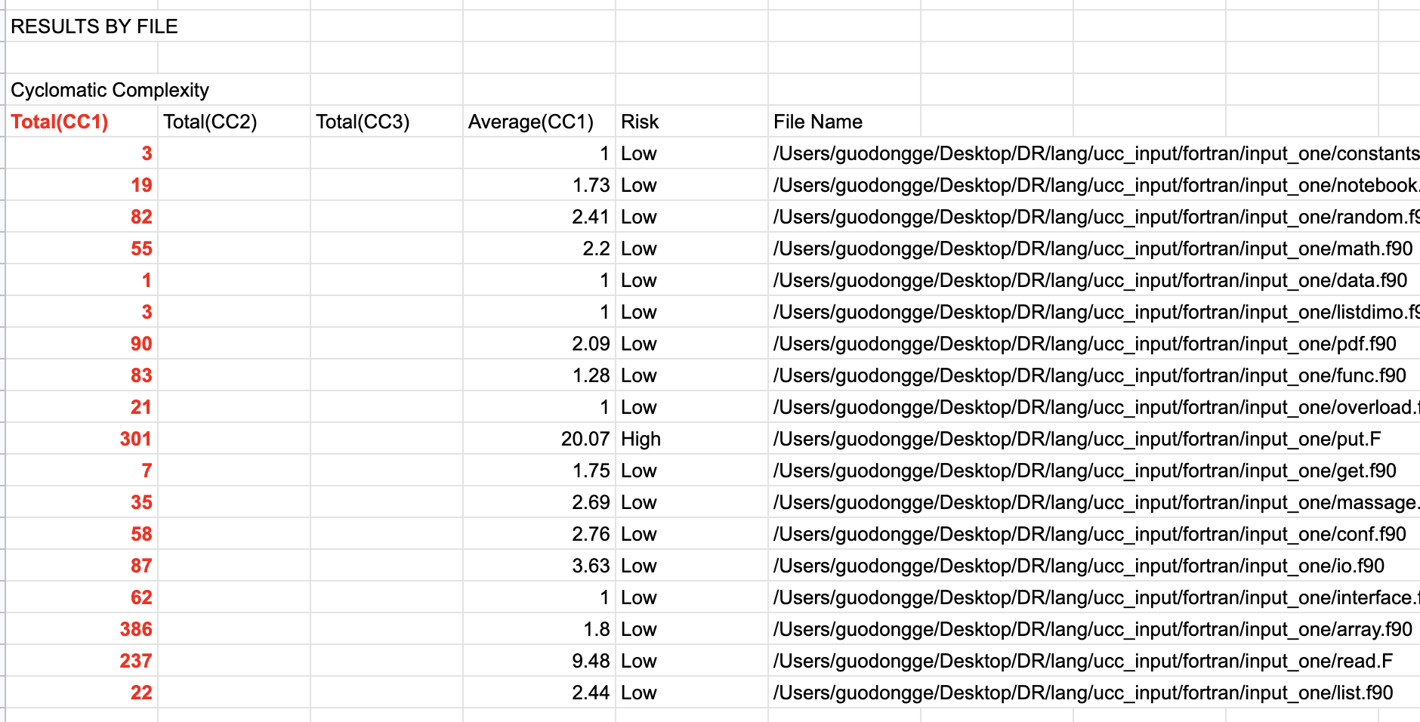

**java_fortran1/outfile_cyclomatic_cplx(result by file)**

**Bug 13:**

**Description :**

About language **IDL**, some keywords count are different between two versions.

**Test Files :**

/ucc_input / idl/ input_one/ *

**Path or file name :**

c++idl1/IDL_outfile

java_idl1/IDL_outfile

**Outputs :**

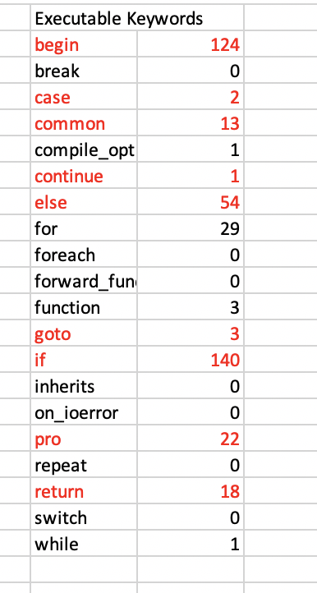

**c++idl1/IDL_outfile**

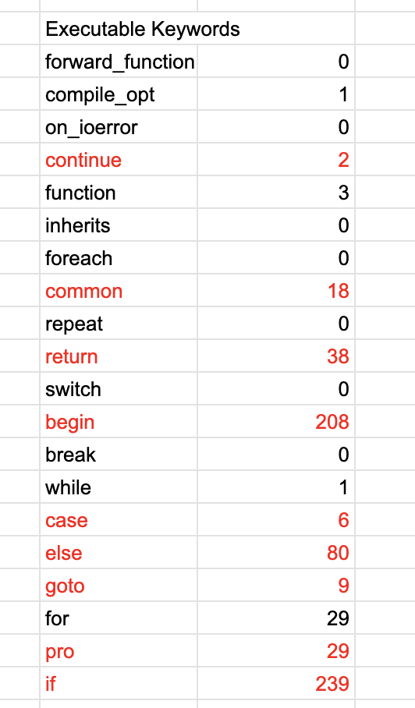

**java_idll1/IDL_outfile**

**Bug 14:**

**Description :**

About language **IDL**, **Math Functions** are different between two versions.

**Test Files :**

/ucc_input / idl/ input_one/ *

**Path or file name :**

c++idl1/outfile_cplx

java_idl1/outfile_cplx

**Outputs :**

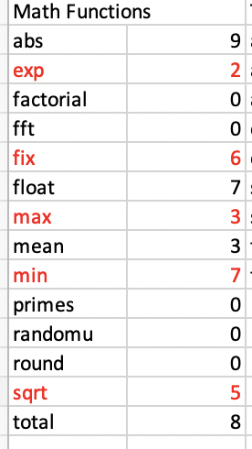

**c++idl1/outfile_cplx**

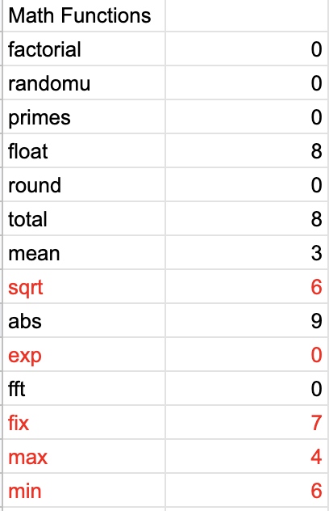

**java_idll1/outfile_cplx**

**Bug 15:**

**Description :**

About language **javascript**, **occurences of keywords** is incorrect.

**Test Files :**

/ucc_input / javascript/ input_one/ *

**Path or file name :**

c++javascript1/outfile_cplx

java_javascript1/outfile_cplx

**Outputs :**

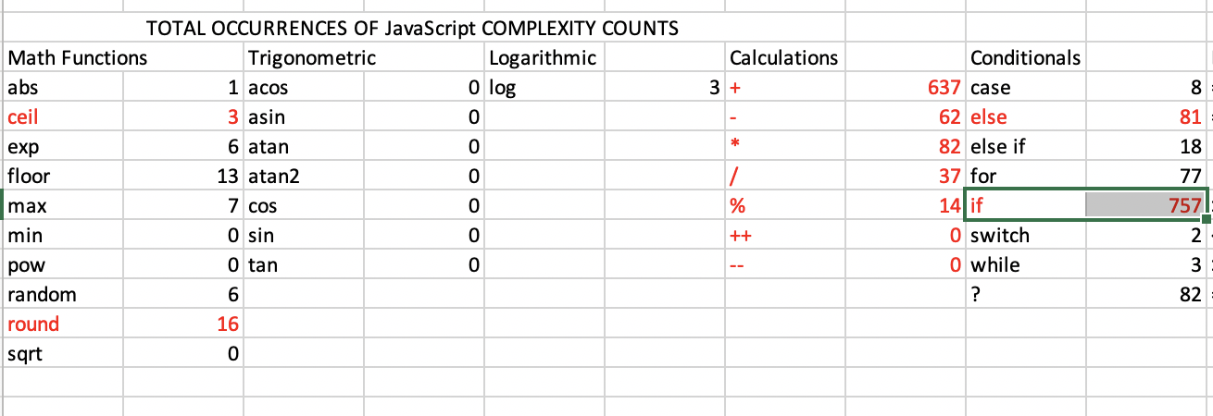

c++javascript1/outfile_cplx

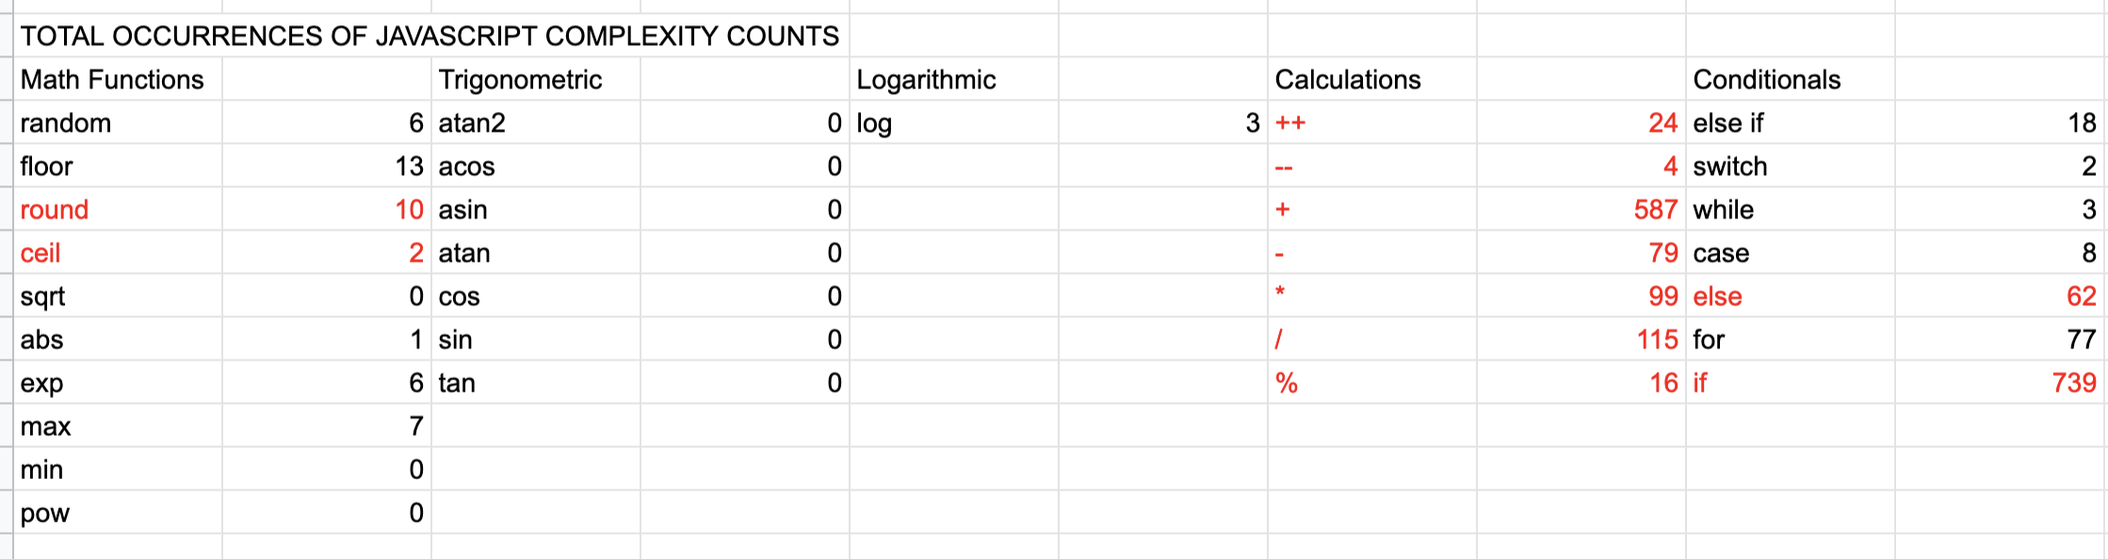

java_javascript1/outfile_cplx

**Two test files : web(2).js and web.js are deleted for they are not js file. Then retest.**

**Reason:**

The occurrence counts are wrong for two different reasons:

1. UCC-Java recognizes the variable “round” in core.js as a math function.
2. When preprocessing, UCC-Java deletes all the code inside “for” parenthesis. All “for” lines become “for () {”, so the math functions and calculations inside the parenthesis are lost. I’m not sure whether this is an expected behavior or a bug. This causes the difference of “ceil” and all the calculations.

**Development Note:**

|  |  |  |
| --- | --- | --- |
| **General Description of New Feature or Code Modification** | | |
| **Modified Files** | **Modified Functions** | **Description** |
| JavaScriptLanguageProperty.java | constructor | **Modify the math keywords as “Math.XXX”:**  SetOtherMathKeywords(new ArrayList<String>(  Arrays.asList("abs", "ceil", "exp", "floor", "max", "min", "pow", "random", "round", "sqrt")));  SetOtherMathKeywords(new ArrayList<String>(  Arrays.asList("Math.abs", "Math.ceil", "Math.exp", "Math.floor", "Math.max", "Math.min", "Math.pow", "Math.random", "Math.round", "Math.sqrt")));  (line 54-55) |

**Bug 16:**

**Description :**

About language **makefile**, **no result of calculations and conditionals of UCC-C++**t.

**Test Files :**

/ucc_input / makefile/ input_one/ *

**Path or file name :**

c++makefile1/outfile_cplx

java_makefilet1/outfile_cplx

**Outputs :**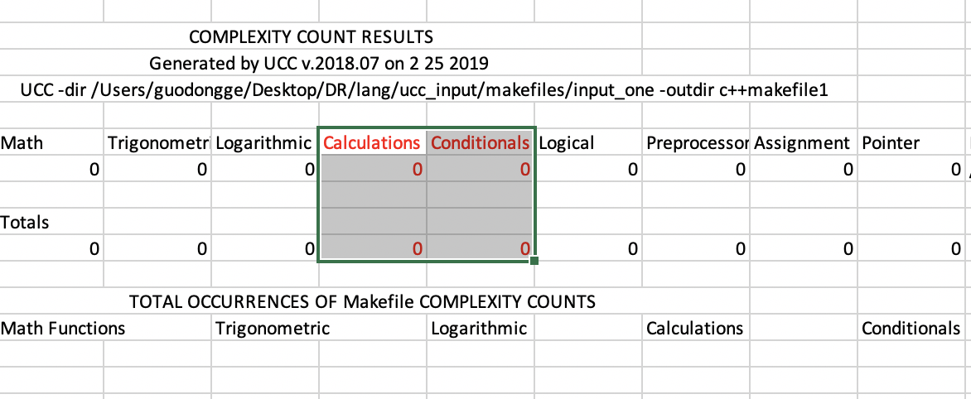

c++makefile1/outfile_cplx

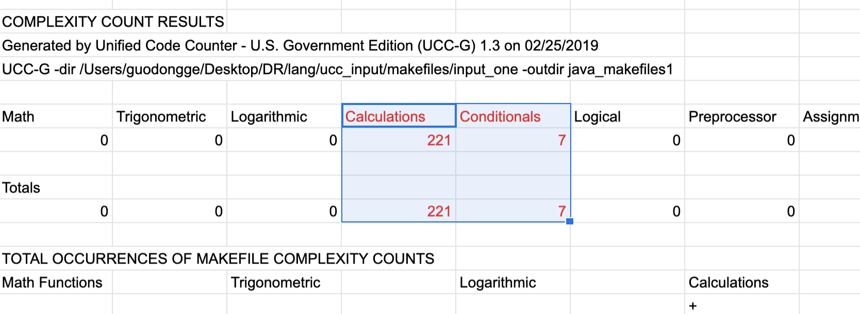

java_makefilet1/outfile_cplx

**Bug 17:**

**Description :**

About language **matlab**, **total functions number and cc1 for some files are incorrect.**t.

**Test Files :**

/ucc_input / matlab/ input_one/ *

**Path or file name :**

c++matlab1/outfile_cyclomatic_cplx

java_matlabt1/outfile_cyclomatic_cplx

**Outputs :**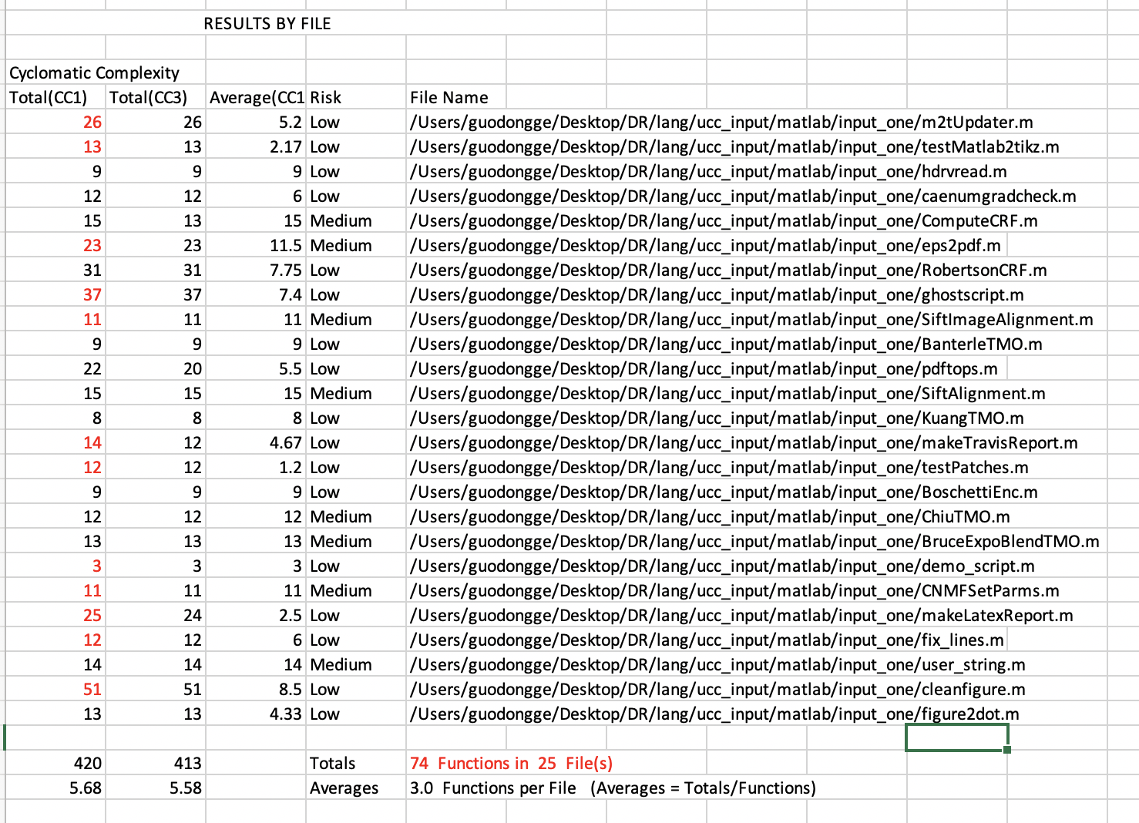

c++matlab1/outfile_cyclomatic_cplx

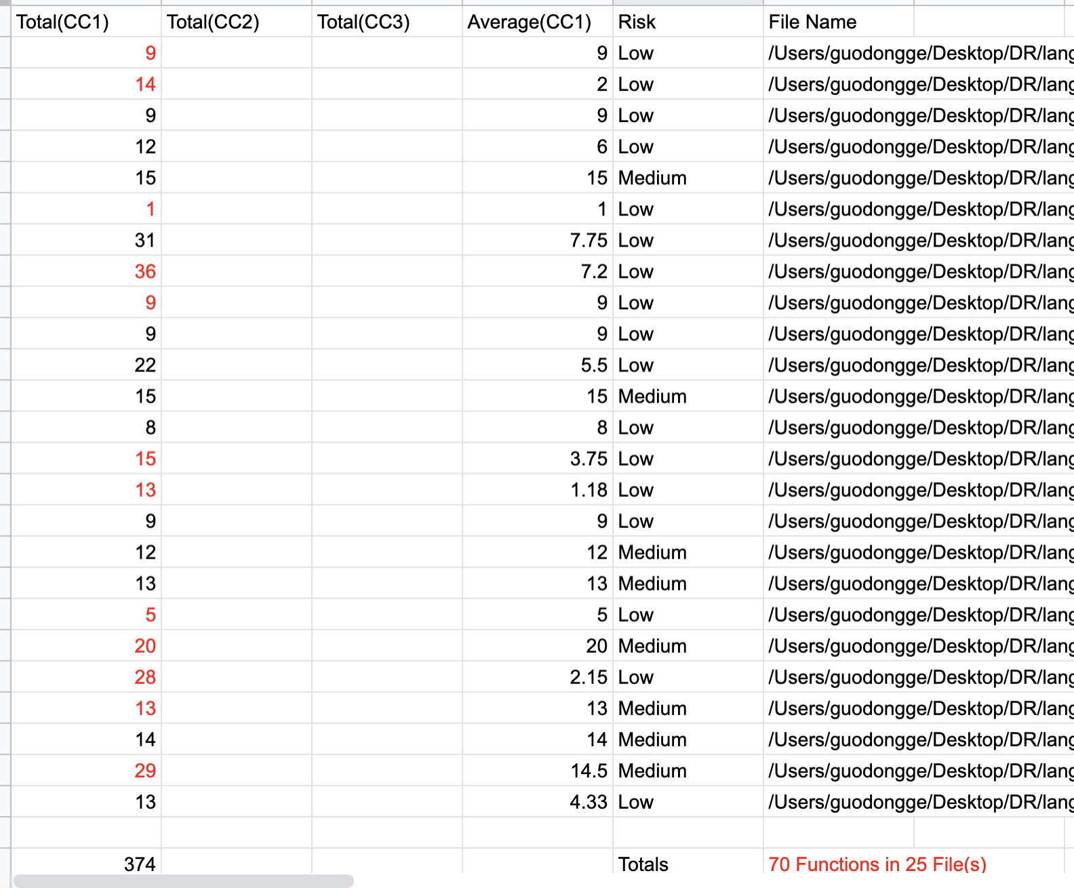

java_matlabt1/outfile_cyclomatic_cplx

**Bug 18:**

**Description :**

About language **matlab**, **some functions name of UCC_JAVA are incorrect.**t.

**Test Files :**

/ucc_input / matlab/ input_one/ *

**Path or file name :**

c++matlab1/outfile_cyclomatic_cplx

java_matlabt1/outfile_cyclomatic_cplx

**Outputs :**

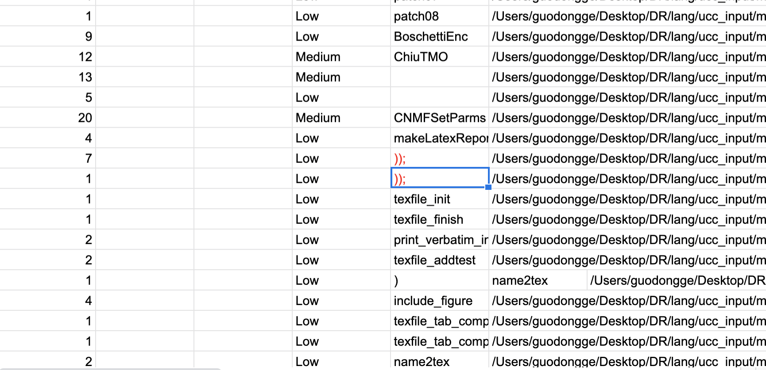

c++matlab1/outfile_cyclomatic_cplx



java_matlabt1/outfile_cyclomatic_cplx

**Bug 19:**

**Description :**

About language **matlab**, **keyword standard are different of UCC_JAVA and UCC_C++.**

**Test Files :**

/ucc_input / matlab/ input_one/ *

**Path or file name :**

c++matlab1/outfile_cyclomatic_cplx

java_matlabt1/outfile_cyclomatic_cplx

**Outputs :**

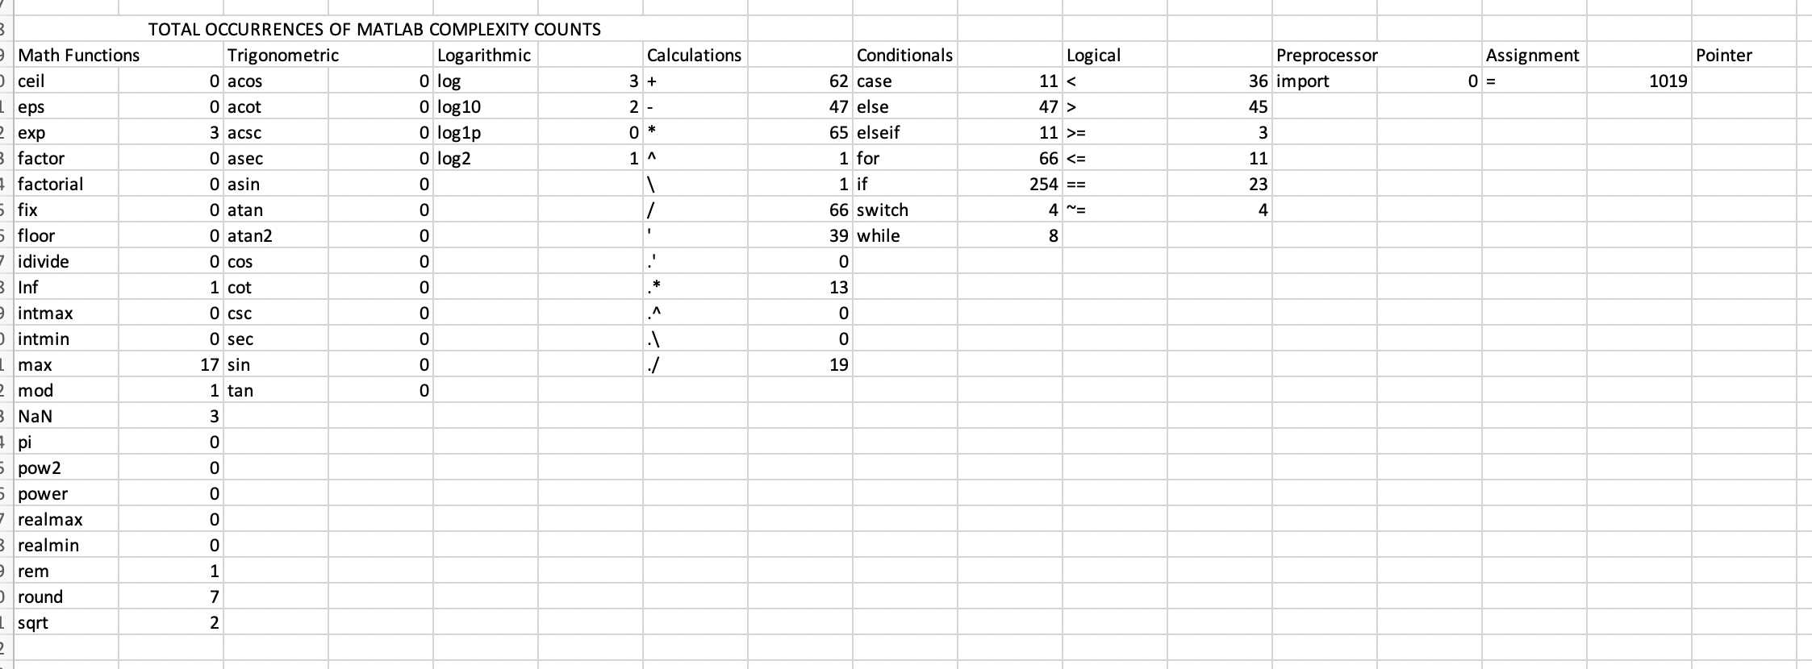

c++matlab1/outfile_cplx

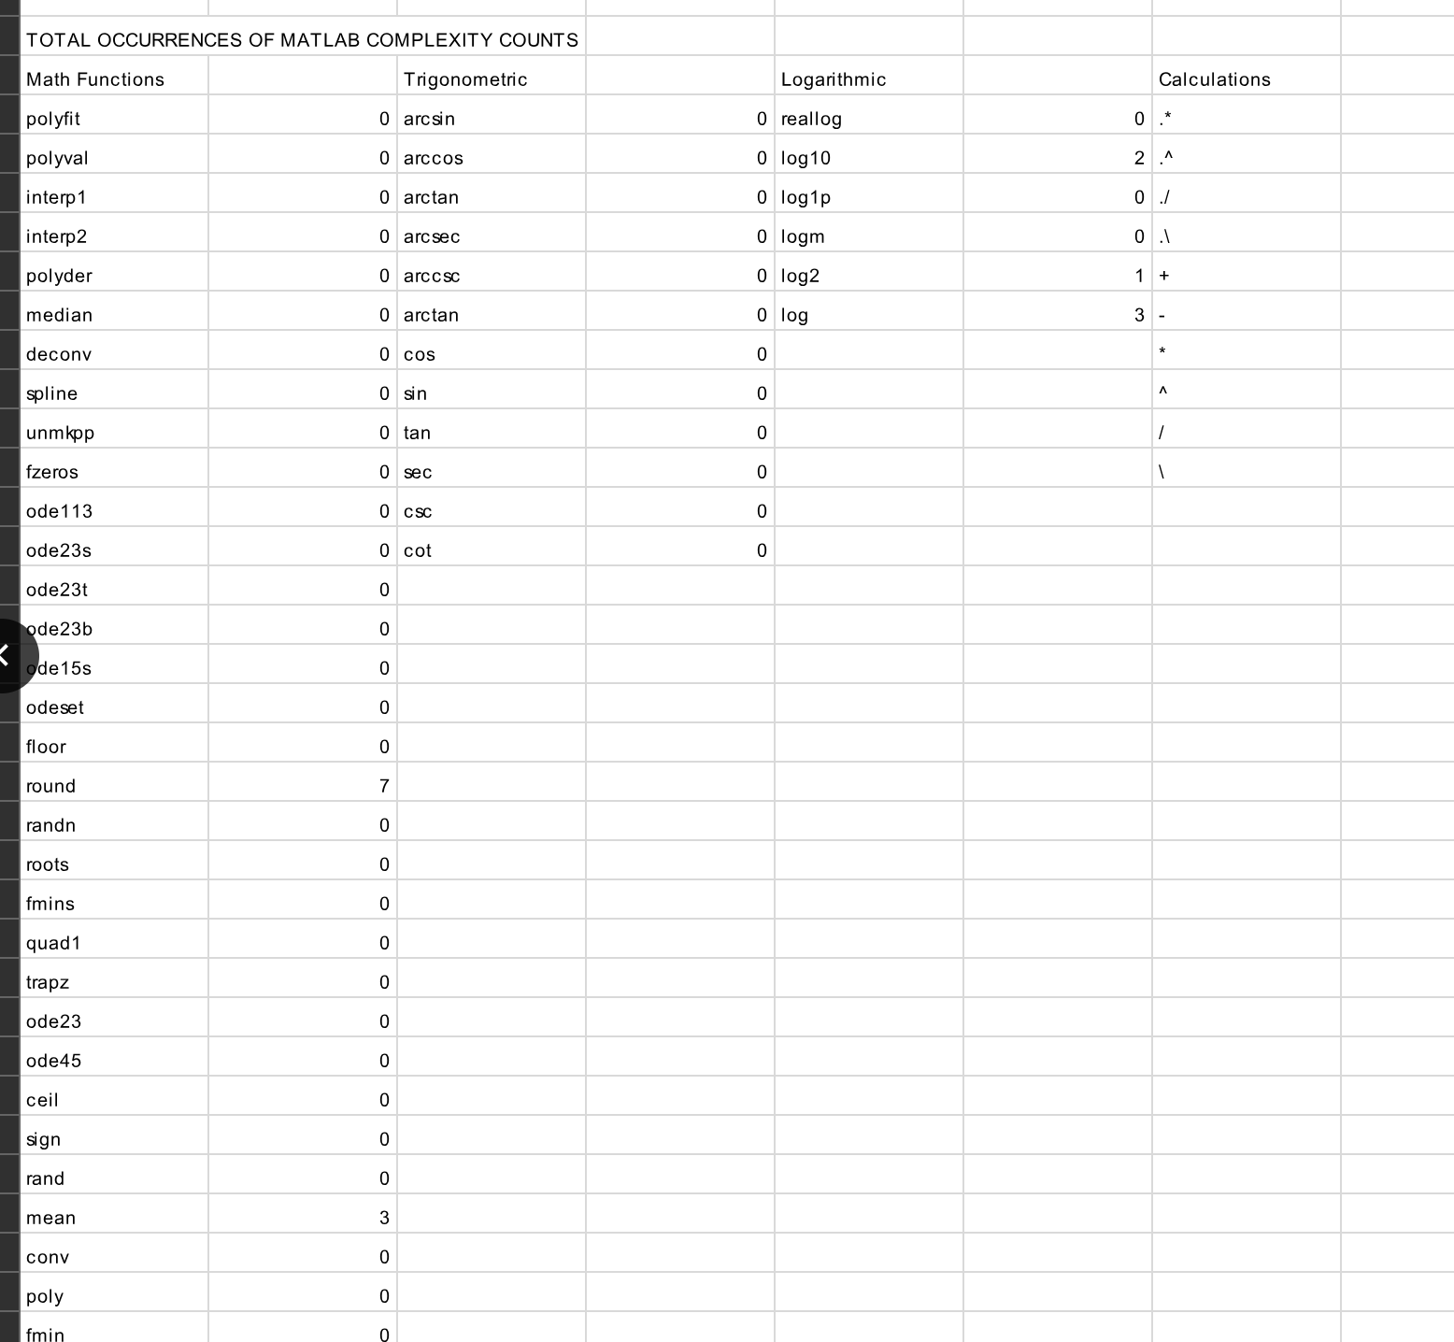

java_matlabt1/outfile_cplx

**Bug 20:**

**Description :**

About language **nextmidas**, **no output of UCC_JAVA.**

**Test Files :**

/ucc_input / nextmidas/ input_one/ *

**Bug 21:**

**Description :**

About language **pascal**, **total function number and cc1 are different of UCC_JAVA and UCC_C++.**

**Test Files :**

/ucc_input / pascal/ input_one/ *

**Path or file name :**

c++matlab1/outfile_cyclomatic_cplx

java_matlabt1/outfile_cyclomatic_cplx

**Outputs :**

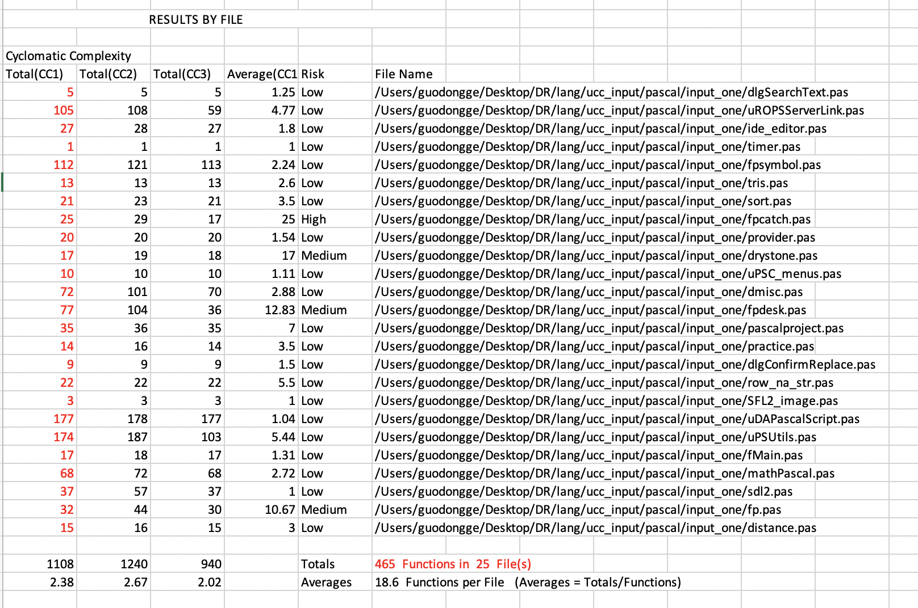

c++matlab1/outfile_cyclomatic_cplx

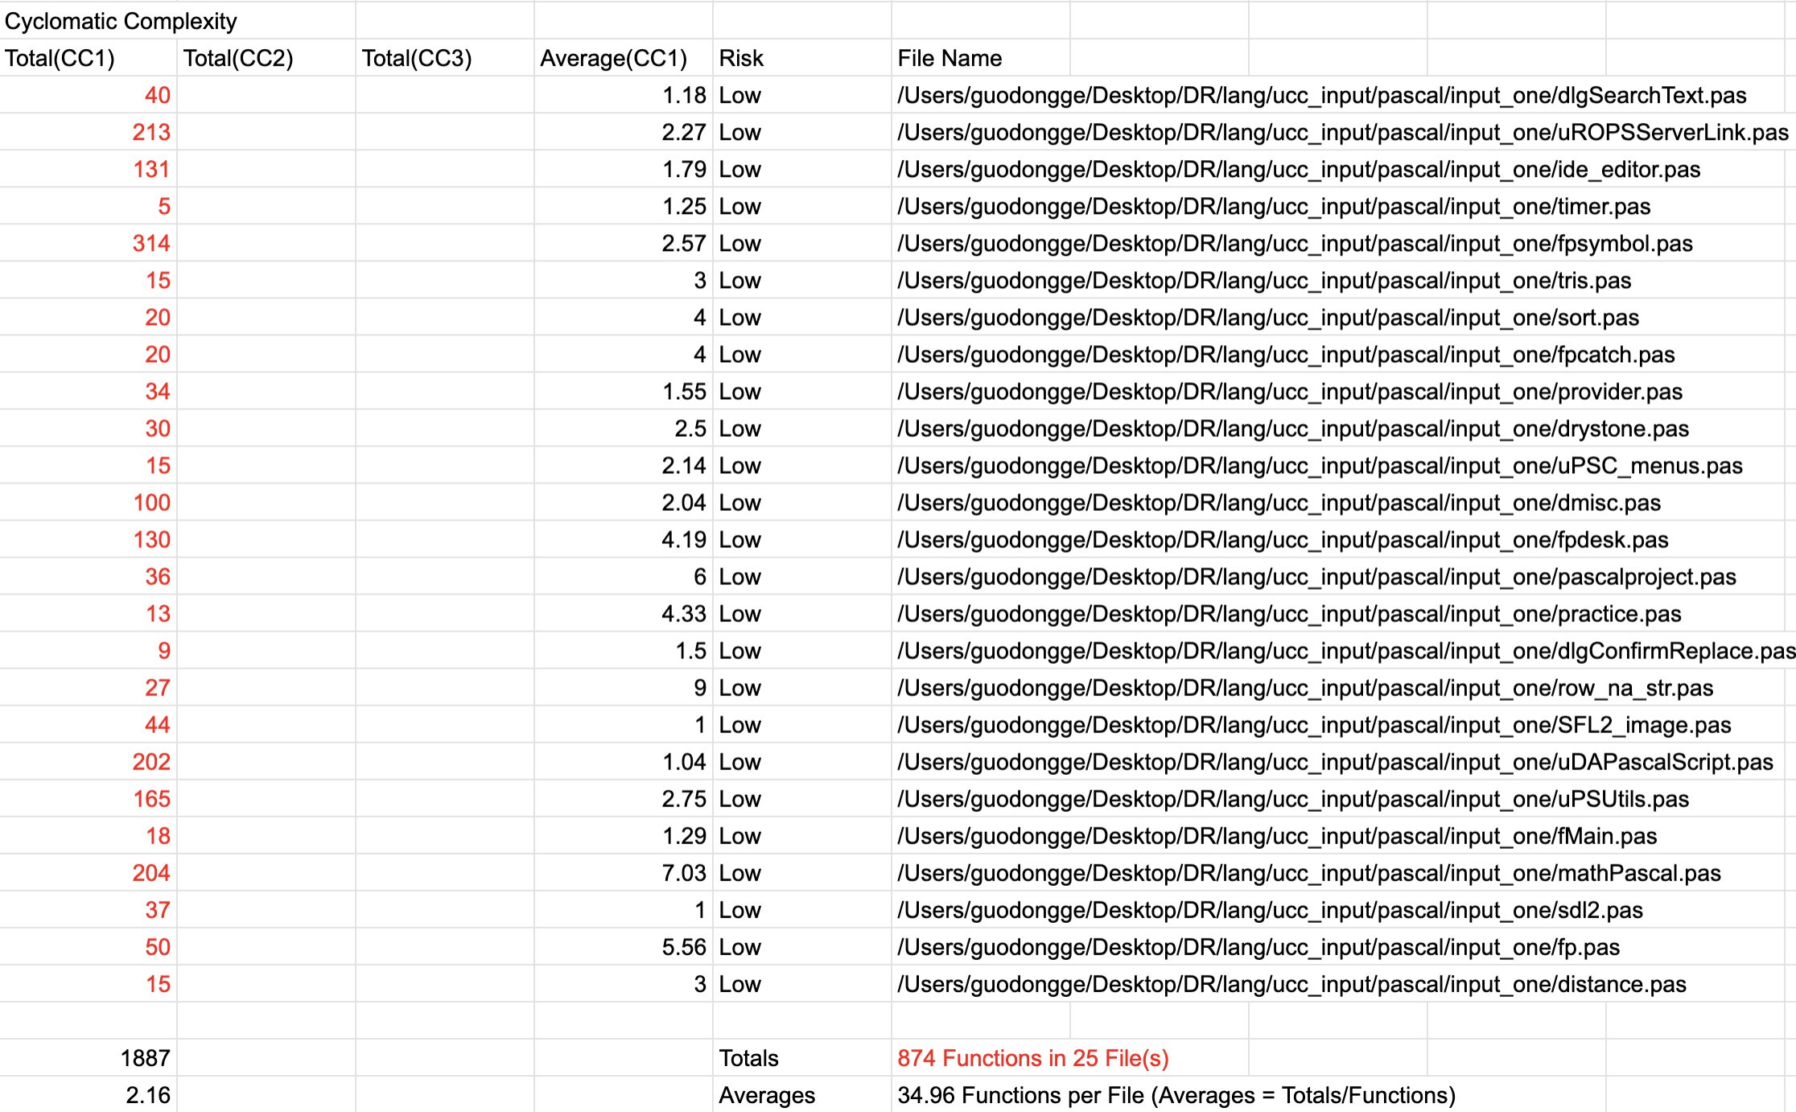

java_matlabt1/outfile_cyclomatic_cplx

**Bug 22:**

**Description :**

About language **matlab**, **keyword calculation are different of UCC_JAVA and UCC_C++.**

**Test Files :**

/ucc_input / pascal/ input_one/ *

**Path or file name :**

c++pascal1/outfile_cplx

java_pascalt1/outfile_cplx

**Outputs :**

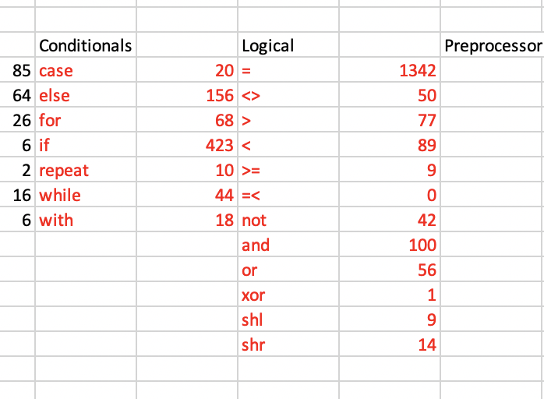

c++pascal1/outfile_cplx

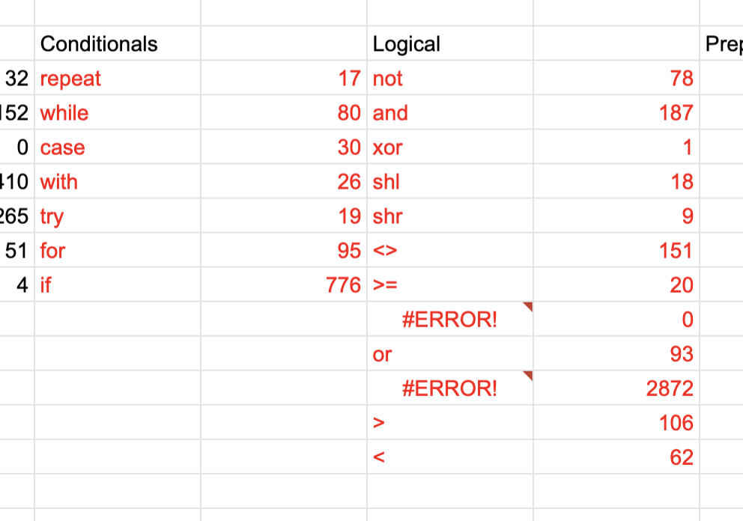

java_pascalt1/outfile_cplx

**Bug 23:**

**Description :**

About language **perl**, **otal function number and cc1 are different of UCC_JAVA and UCC_C++.**

**Test Files :**

/ucc_input / perl/ input_one/ *

**Path or file name :**

c++perl1/outfile_cyclomatic_cplx

java_perl1/outfile_cyclomatic_cplx

**Outputs :**

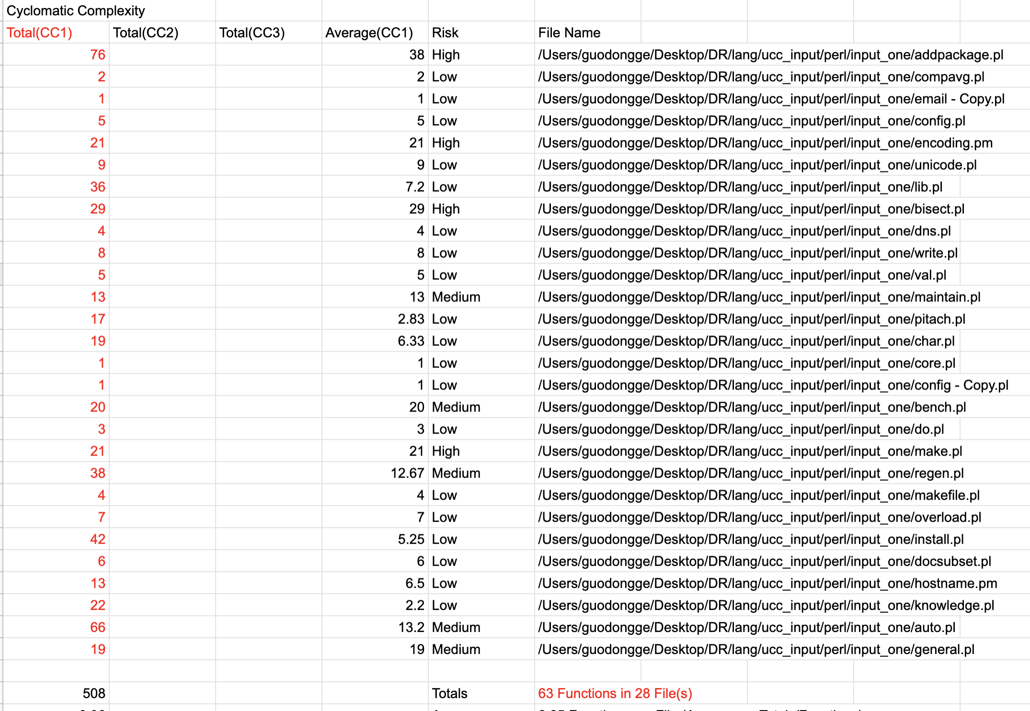

c++perl1/outfile_cyclomatic_cplx

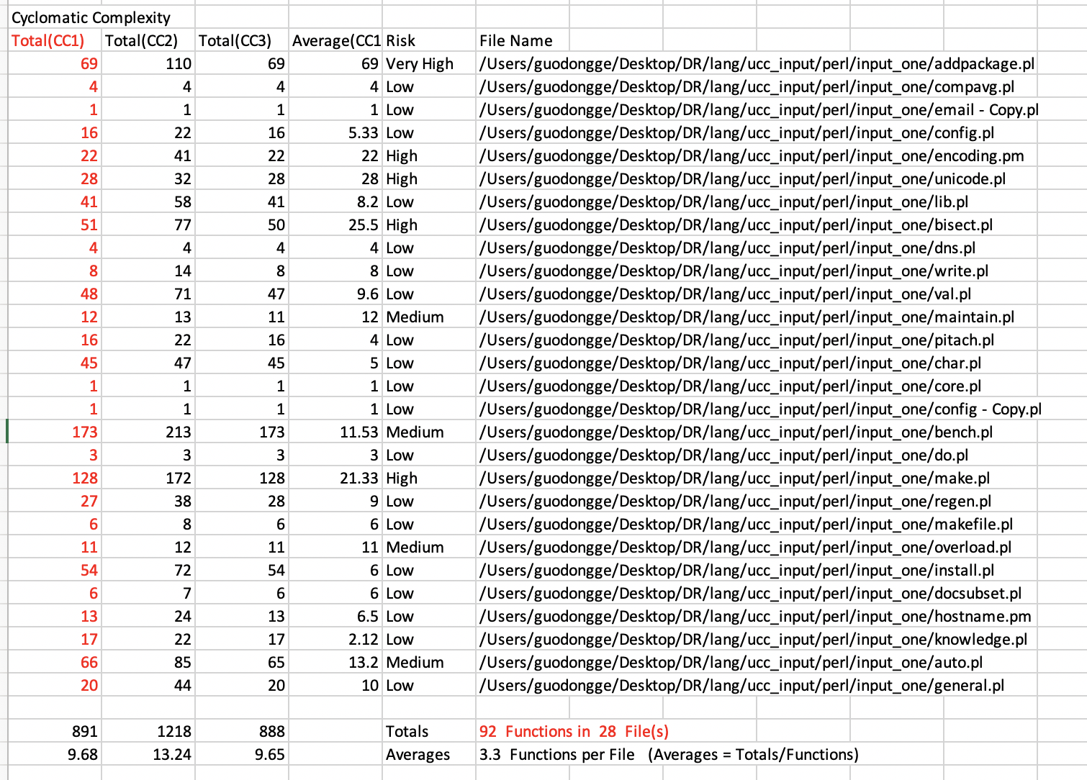

java_perl1/outfile_cyclomatic_cplx

**Bug 24:**

**Description :**

About language **perl**, **some function name of UCC_JAVA are incorrect.**

**Test Files :**

/ucc_input / perl/ input_one/ *

**Path or file name :**

c++perl1/outfile_cyclomatic_cplx

java_perl1/outfile_cyclomatic_cplx

**Outputs :**

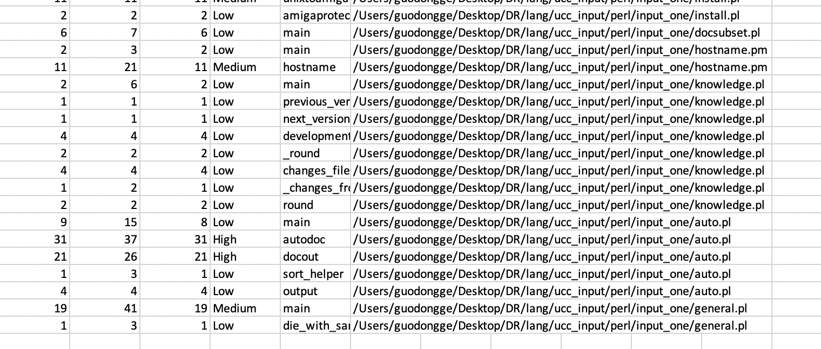

c++perl1/outfile_cyclomatic_cplx

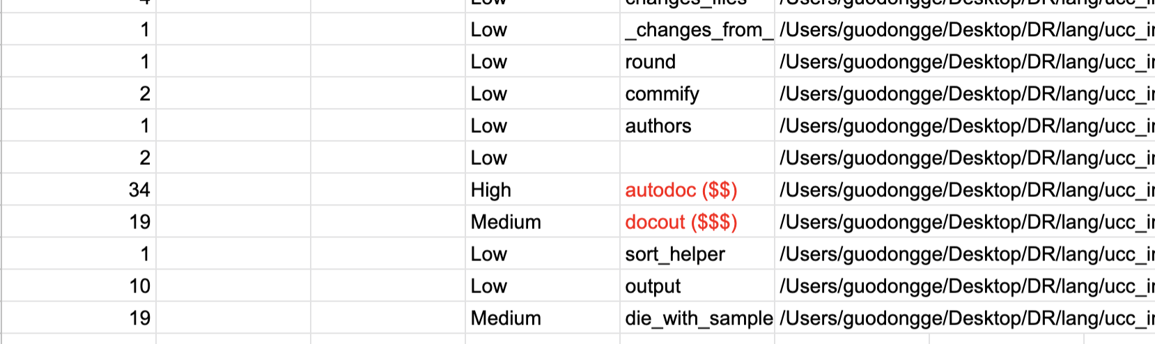

java_perl1/outfile_cyclomatic_cplx

**Bug 25:**

**Description :**

About language **php**, **some keywords count are incorrect.**

**Test Files :**

/ucc_input / php/ input_one/ *

**Path or file name :**

c++php1/outfile_cplx

java_php1/outfile_cplx

**Outputs :**

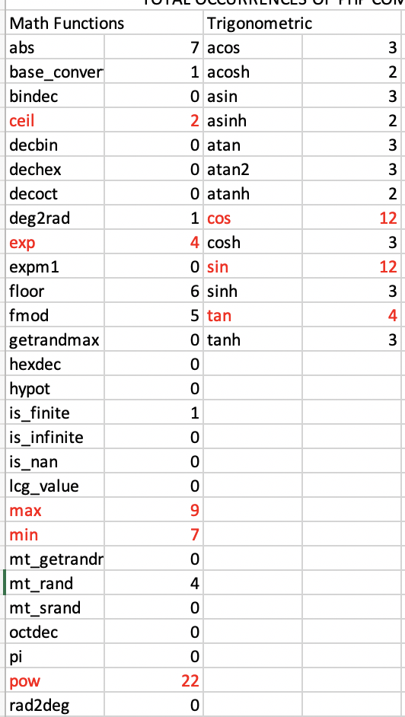

c++php1/outfile_cplx

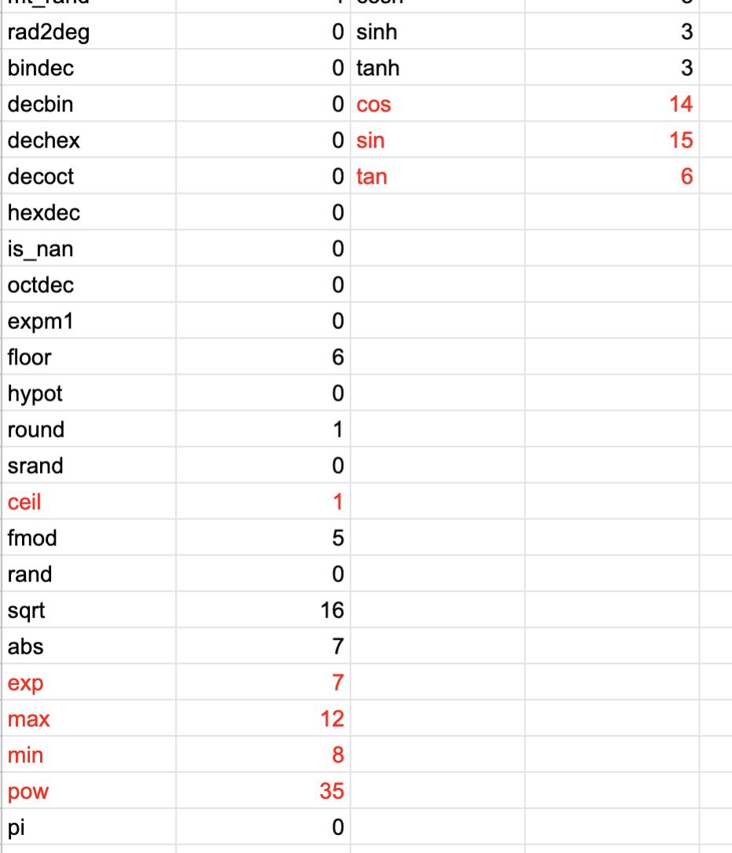

java_php1/outfile_cplx

**Bug 38:**

**Description :**

About language **ruby**, **some keywords count are incorrect.**

**Test Files :**

/ucc_input / ruby/ input_one/ *

**Path or file name :**

c++ruby1/outfile_cplx

java_ruby1/outfile_cplx

**Outputs :**

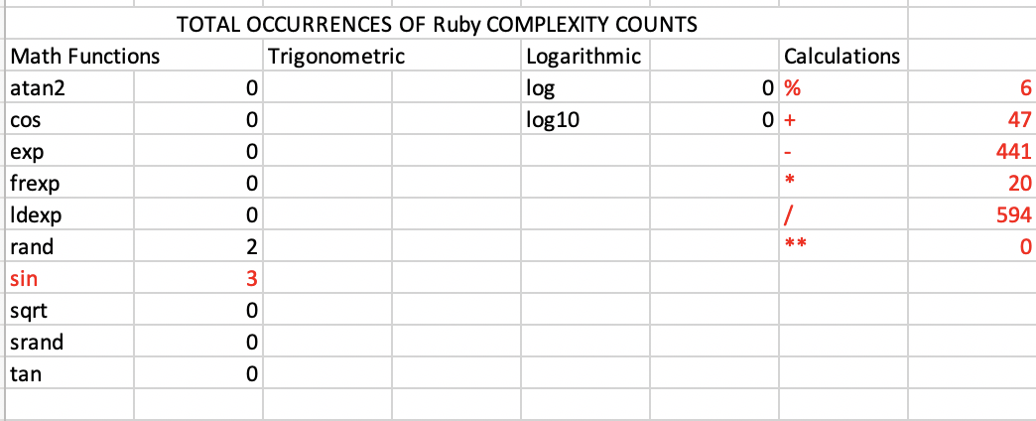

c++ruby1/outfile_cplx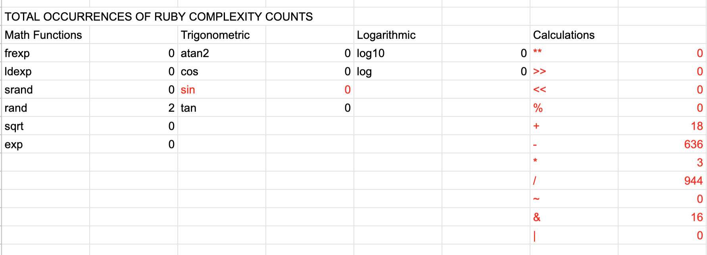

java_ruby1/outfile_cplx

**Bug 39:**

**Description :**

About language **ruby**, **CC1 count and total functions are incorrect.**

**Test Files :**

/ucc_input / ruby/ input_one/ *

**Path or file name :**

c++ruby1/outfile_cylomatic_cplx

java_ruby1/outfile_cyclomatic_cplx

**Outputs :**

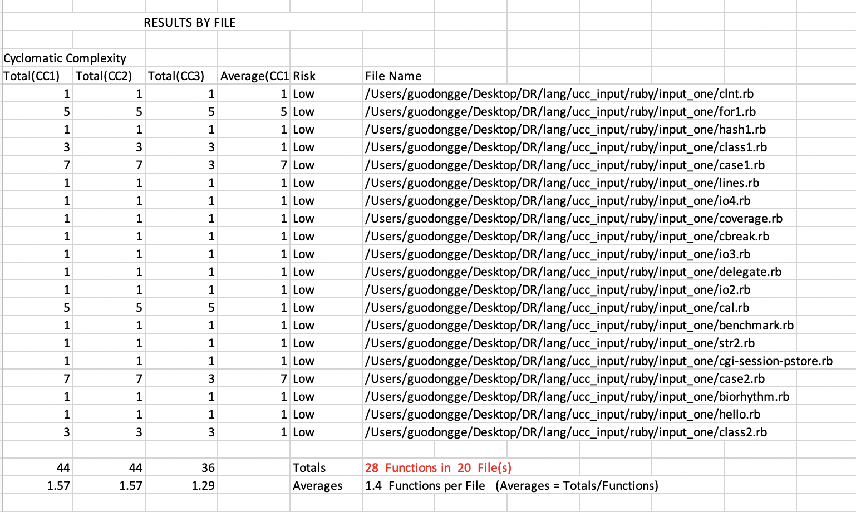

c++ruby1/outfile_cylomatic_cplx

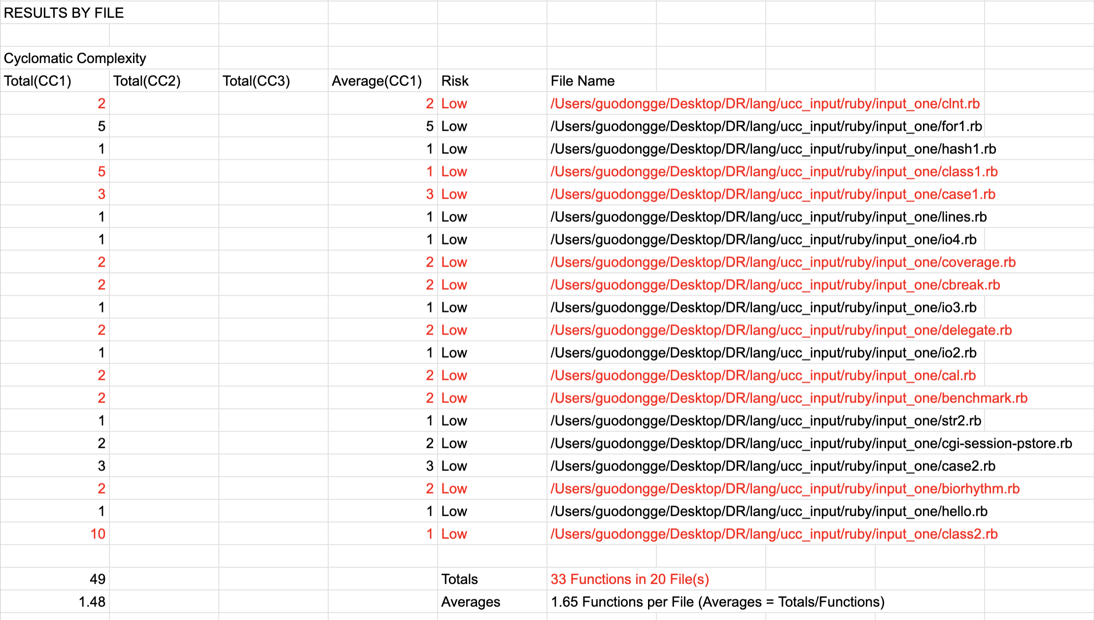

java_rubby1/outfile_cyclomatic_cplx

**Bug 26:**

**Description :**

About language **ruby**, **some function names are incorrect.**

**Test Files :**

/ucc_input / ruby/ input_one/ *

**Path or file name :**

c++ruby1/outfile_cylomatic_cplx

java_ruby1/outfile_cyclomatic_cplx

**Outputs :**

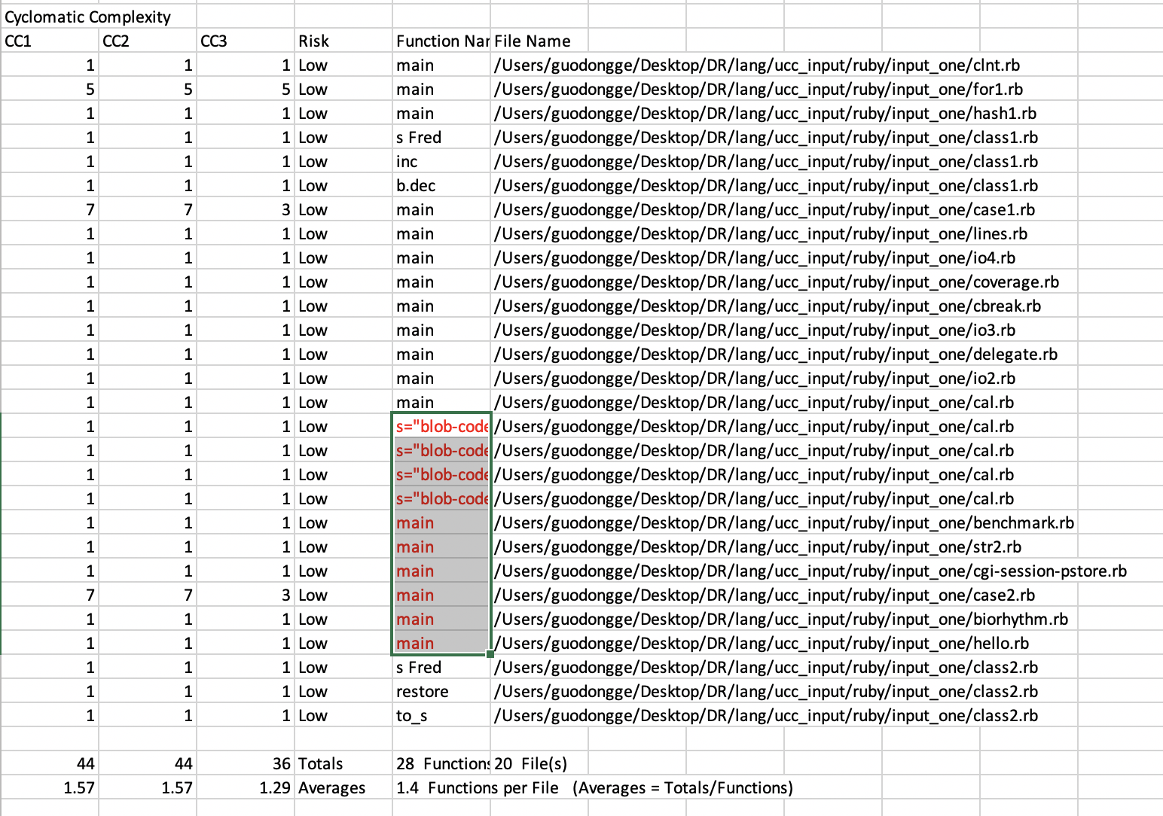

c++ruby1/outfile_cylomatic_cplx

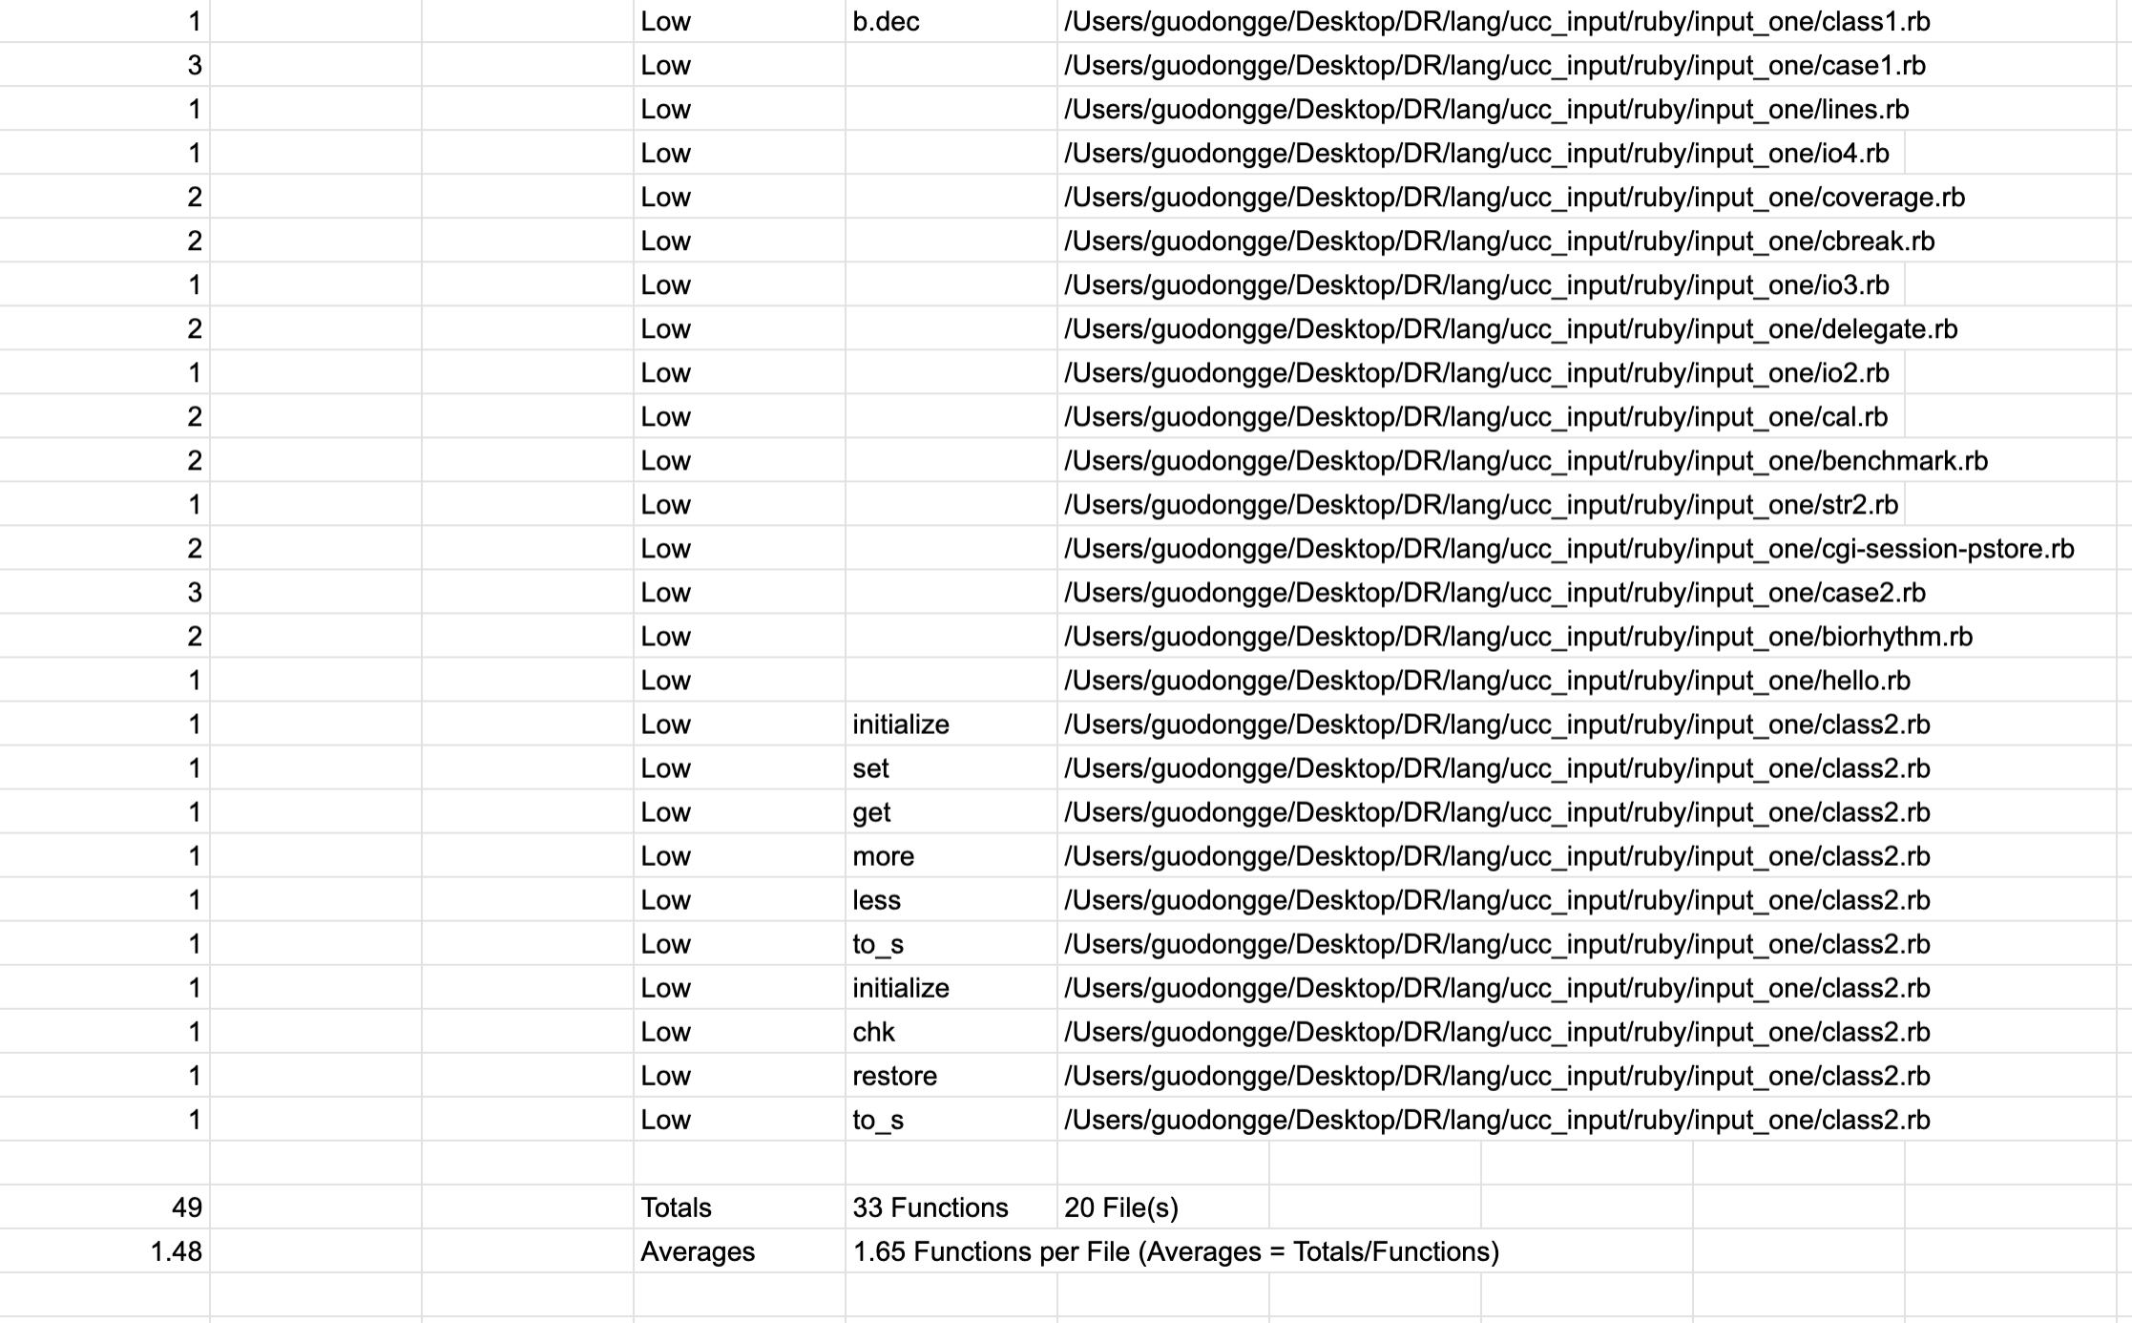

java_ruby1/outfile_cyclomatic_cplx

**Bug 27:**

**Description :**

About language **scala**, **some keywords count are incorrect.**

**Test Files :**

/ucc_input / scala/ input_one/ *

**Path or file name :**

c++scala1/outfile_cplx

java_scala1/outfile_cplx

**Outputs :**

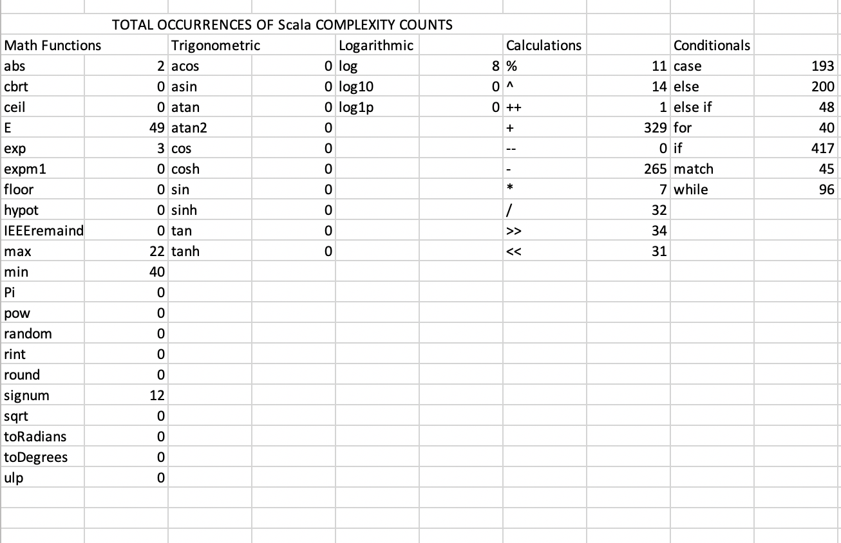

c++scala1/outfile_cplx

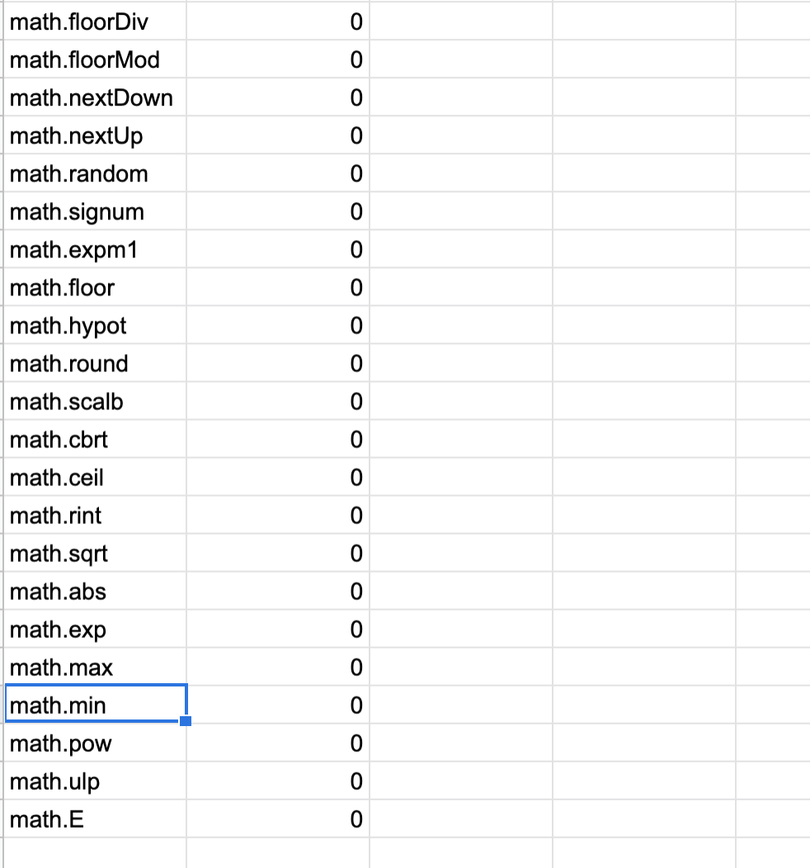

java_scala1/outfile_cplx

**Bug 28:**

**Description :**

About language **scala**, **total function number and total CC1 are incorrect.**

**Test Files :**

/ucc_input / scala/ input_one/ *

**Path or file name :**

c++scala1/outfile_cylomatic_cplx

java_scala1/outfile_cyclomatic_cplx

**Outputs :**

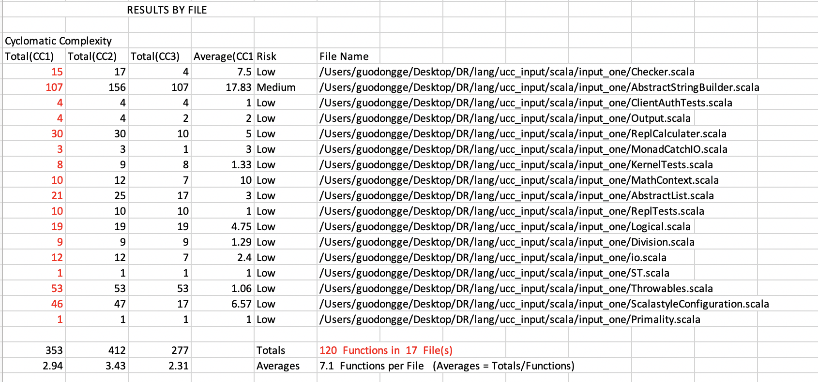

c++scala1/outfile_cylomatic_cplx

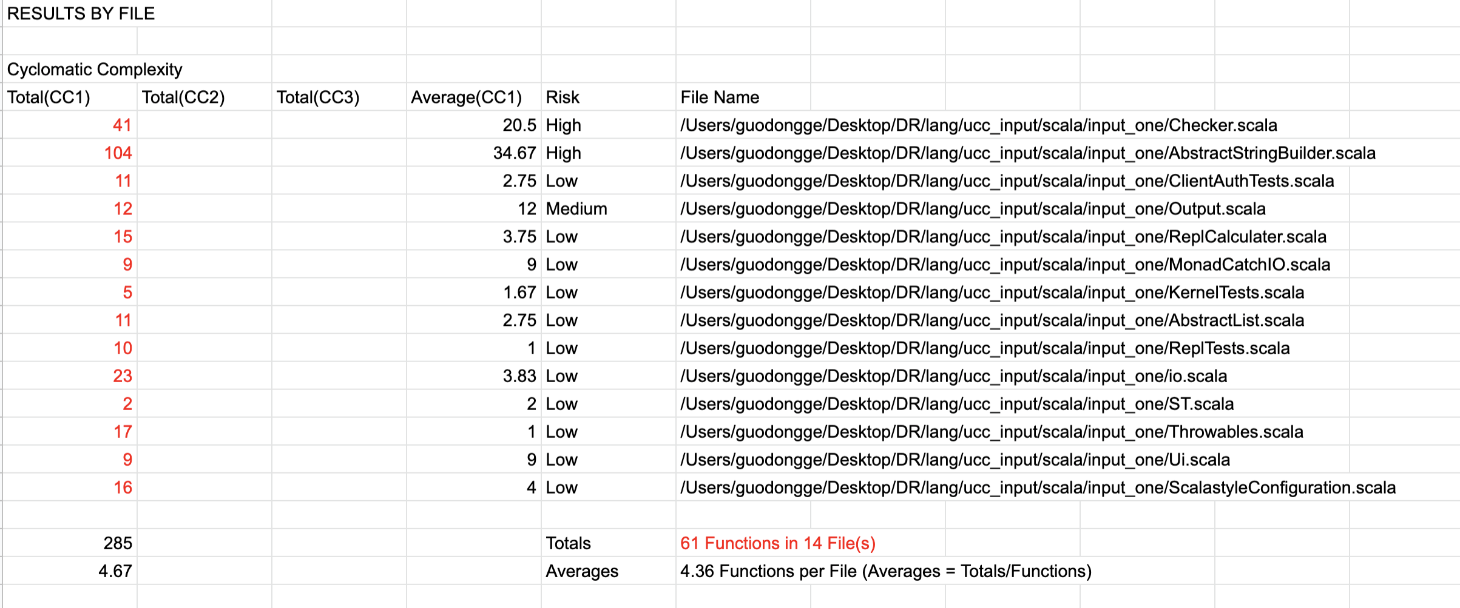

java_scala1/outfile_cyclomatic_cplx

**Bug 29:**

**Description :**

About language **sql**, **some keyword count are incorrect.**

**Test Files :**

/ucc_input / sql/ input_one/ *

**Path or file name :**

c++sql1/outfile_cplx

java_sql1/outfile_cplx

**Outputs :**

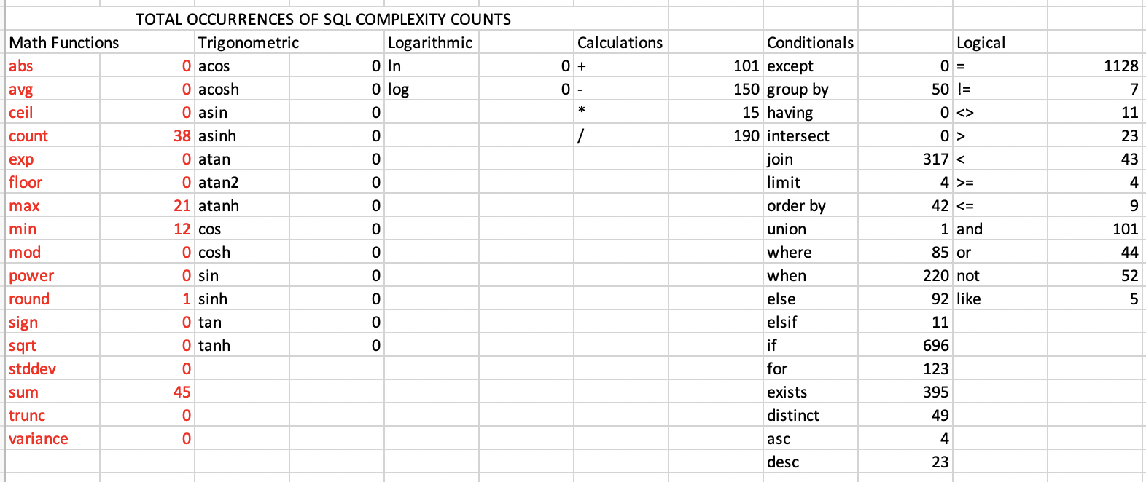

c++sql1/outfile_cplx

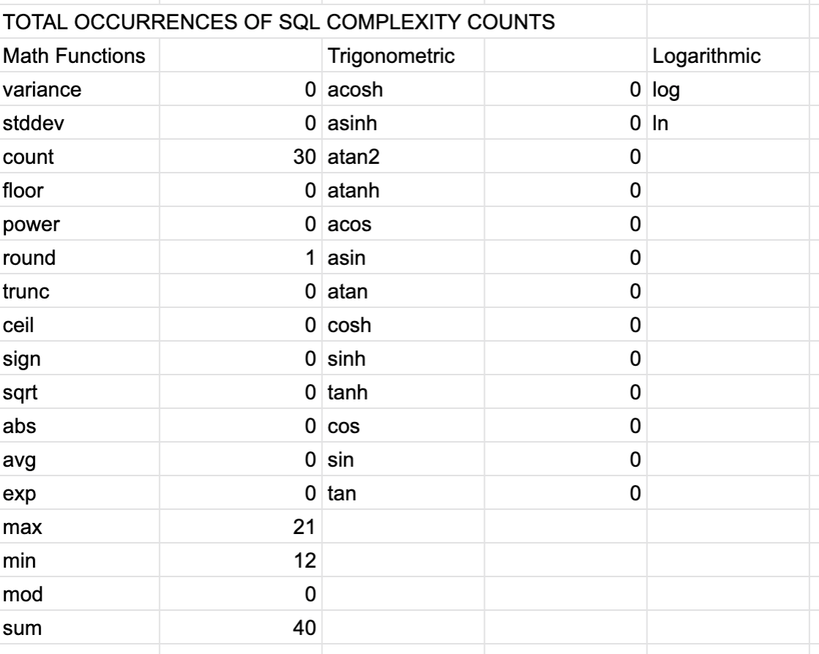

java_sql1/outfile_cplx

**Bug 30:**

**Description :**

About language **vb, some keyword count are incorrect.**

**Test Files :**

/ucc_input / vb / input_one/ *

**Path or file name :**

c++vb1/outfile_cplx

java_vb1/outfile_cplx

**Outputs :**

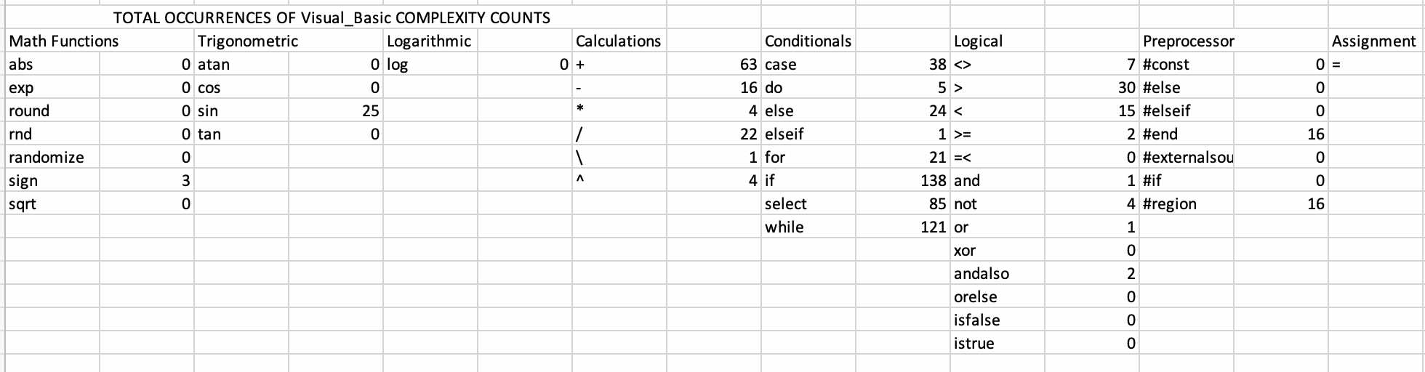

c++vb1/outfile_cplx

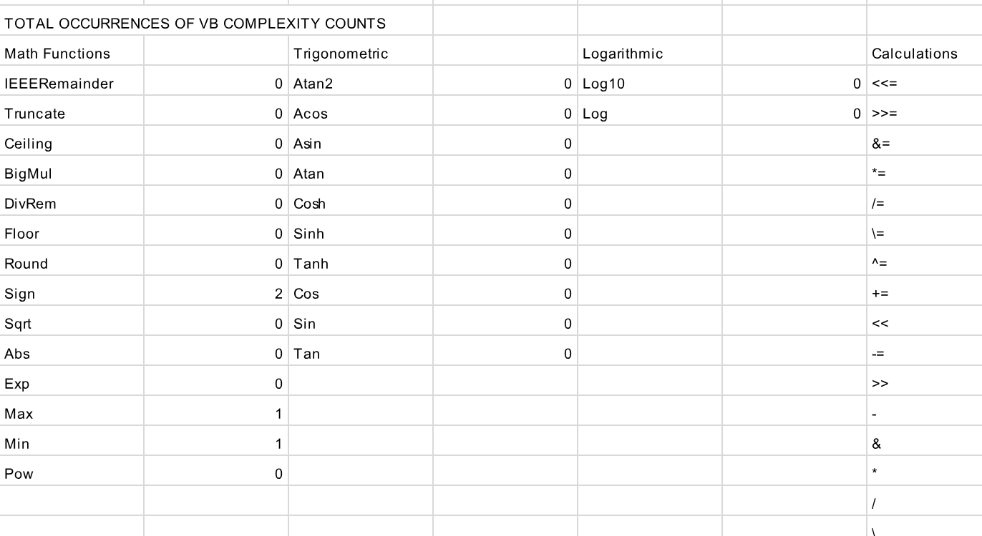

java_vb1/outfile_cplx

**Bug 31:**

**Description :**

About language **vb script, some keyword count are incorrect.**

**Test Files :**

/ucc_input / vbscript / input_one/ *

**Path or file name :**

c++vbscript1/outfile_cplx

java_vbscript1/outfile_cplx

**Outputs :**

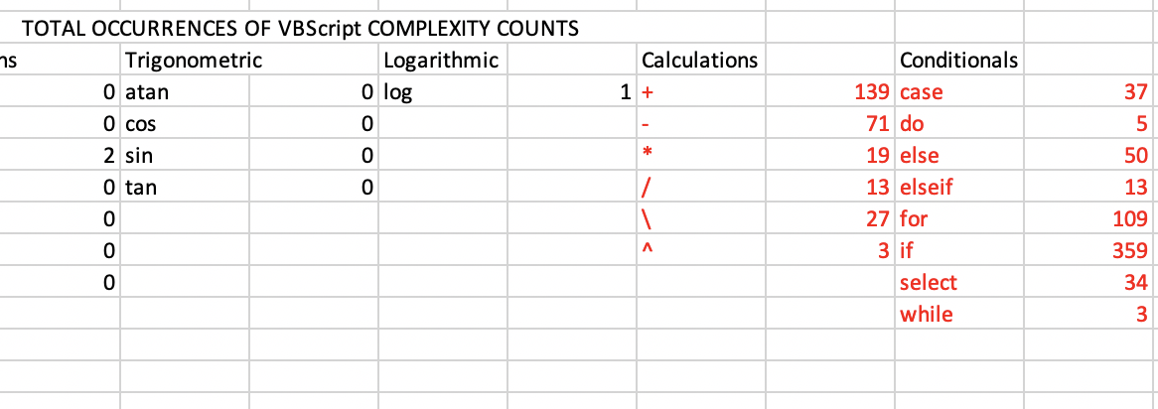

c++vbscript1/outfile_cplx

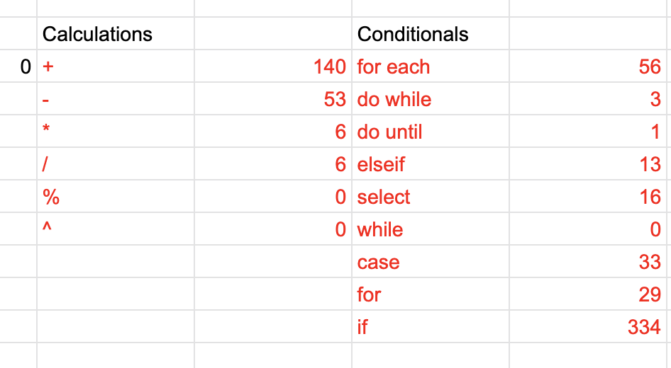

java_vbscript1/outfile_cplx

**Bug 32:**

**Description :**

About language **verilog, some keyword count are incorrect.**

**Test Files :**

/ucc_input / verilog / input_one/ *

**Path or file name :**

c++verilog1/outfile_cplx

java_verilog1/outfile_cplx

**Outputs :**

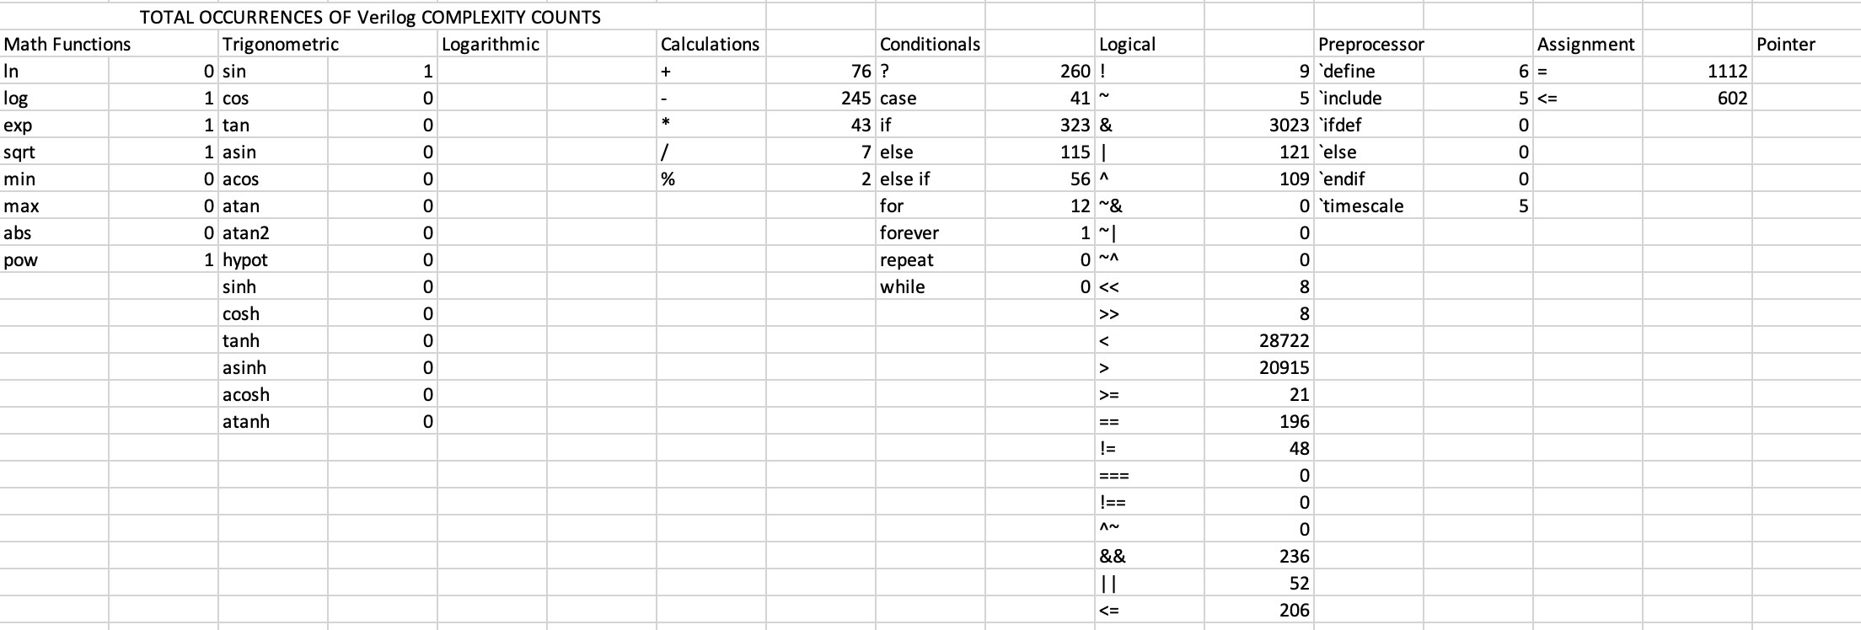

c++verilog1/outfile_cplx

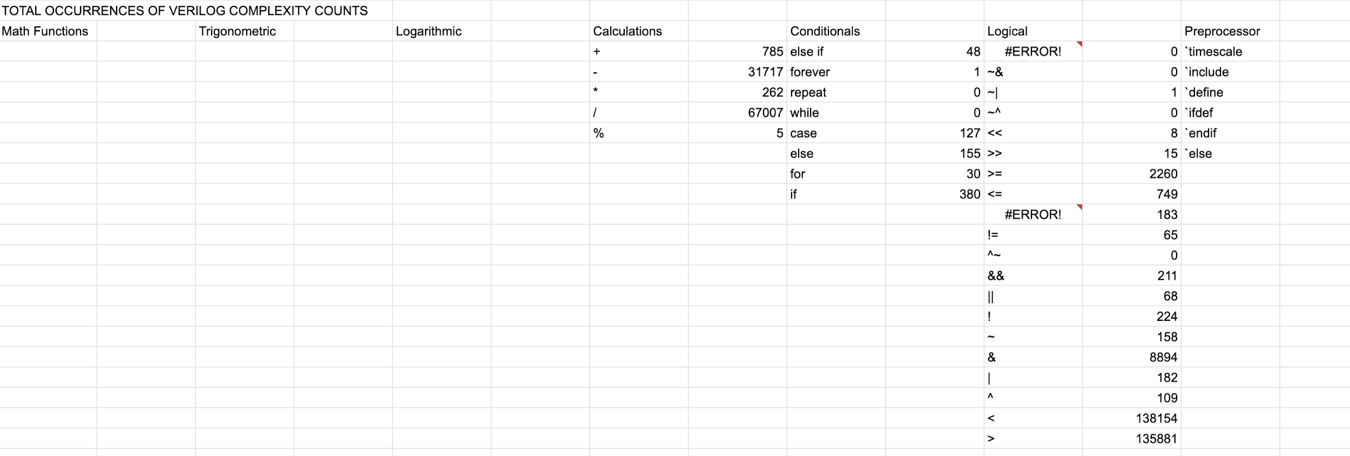

java_verilog1/outfile_cplx

**Bug 33:**

**Description :**

About language **VHDL, some keyword count are incorrect.**

**Test Files :**

/ucc_input / VHDL / input_one/ *

**Path or file name :**

c++VHDL1/outfile_cplx

java_VHDL1/outfile_cplx

**Outputs :**

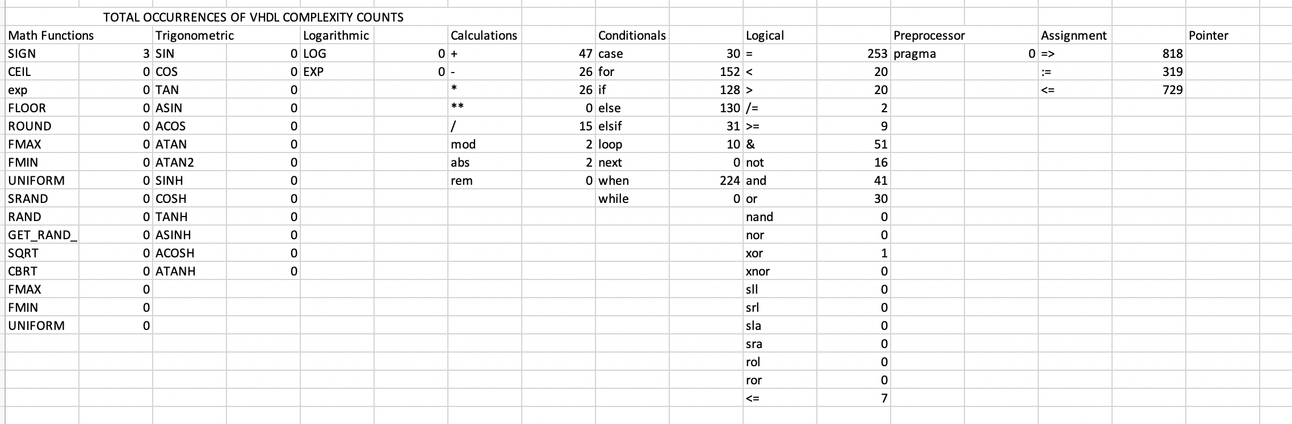

c++VHDL1/outfile_cplx

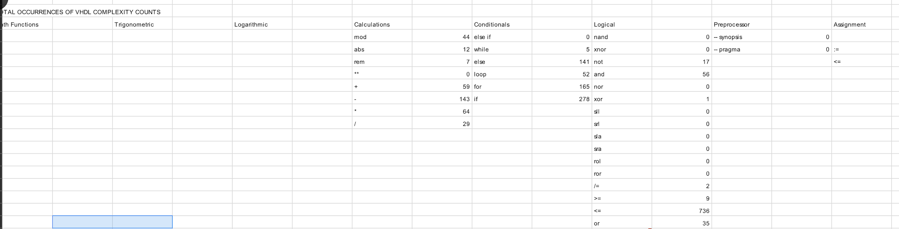

java_VHDL1/outfile_cplx

**Bug 34:**

**Description :**

About language **xmidas, no output of UCC-JAVA and UCC-C++.**

**Test Files :**

/ucc_input / xmidas / input_one/ *

**Path or file name :**

NONE

**Outputs :**

NONE